UNITED STATES
SECURITIES AND EXCHANGE COMMISSION
Washington, D.C. 20549
FORM 8-K
CURRENT REPORT
Pursuant to Section 13 or 15(d)
of the Securities Exchange Act of 1934
Date of Report (Date of earliest event reported): July 28, 2026
ALDEYRA THERAPEUTICS, INC.
(Exact name of Registrant as specified in its charter)
Delaware |  | 001-36332 |  | 20-1968197
(State or other jurisdiction  of incorporation) |  | (Commission  File No.) |  | (IRS Employer  Identification No.)
131 Hartwell Avenue, Suite 320
Lexington, MA 02421
(Address of principal executive offices and zip code)
Registrant’s telephone number, including area code: (781) 761-4904
Not Applicable
(Former Name or Former Address, if Changed Since Last Report)
Check the appropriate box below if the Form 8-K filing is intended to simultaneously satisfy the filing obligation of the registrant under any of the following provisions:
☐ | Written communications pursuant to Rule 425 under the Securities Act (17 CFR 230.425)
☐ | Soliciting material pursuant to Rule 14a-12 under the Exchange Act (17 CFR 240.14a-12)
☐ | Pre-commencement communications pursuant to Rule 14d-2(b) under the Exchange Act (17 CFR 240.14d-2(b))
☐ | Pre-commencement communications pursuant to Rule 13e-4(c) under the Exchange Act (17 CFR 240.13e-4(c))

Securities registered pursuant to Section 12(b) of the Act:
Title of each class |  | Trading  Symbol(s) |  | Name of each exchange  on which registered
Common Stock, $0.001 par value per share |  | ALDX |  | The Nasdaq Stock Market LLC
Indicate by check mark whether the registrant is an emerging growth company as defined in Rule 405 of the Securities Act of 1933 (§230.405 of this chapter) or Rule 12b-2 of the Securities Exchange Act of 1934 (§240.12b-2 of this chapter).
Emerging growth company ☐
If an emerging growth company, indicate by check mark if the registrant has elected not to use the extended transition period for complying with any new or revised financial accounting standards provided pursuant to Section 13(a) of the Exchange Act. ☐

Item 1.01. | Entry into a Material Definitive Agreement.
On July 28, 2026, Aldeyra Therapeutics, Inc. (“Aldeyra” or the “Company”) executed a lease agreement (the “Office Lease”) with Bradford Street, L.L.C. (“Bradford Street”) for approximately 4,067 square feet of office space located at 23 Bradford Street, Concord, Massachusetts (the “Premises”). The Office Lease commences on September 1, 2026 and the term with respect to the Premises shall be for a period ending on September 30, 2029. The Company intends to use the Premises as its corporate headquarters. The Office Lease provides for a monthly base rent of $12,201.00, increasing each year as indicated in the Office Lease (the “Base Rent”). In addition to the Base Rent, the Company is required to pay Bradford Street certain operating expenses, taxes, and other fees in accordance with the terms of the Office Lease. The Office Lease contains customary representations and covenants regarding occupancy, maintenance, and care of the Premises. The Company will post an initial security deposit in the amount of $50,000.00.
The foregoing description of the Office Lease does not purport to be complete and is qualified in its entirety by the full text of the Office Lease, a copy of which is filed as Exhibit 10.1 to this Current Report on Form 8-K and is incorporated by reference herein.

Item 9.01. | Financial Statements and Exhibits.
(d) Exhibits

Exhibit  No. |  | Description
10.1 |  | Lease Agreement by and between Bradford Street, L.L.C. and Aldeyra Therapeutics, Inc.

SIGNATURE
Pursuant to the requirements of the Securities Exchange Act of 1934, the registrant has duly caused this report to be signed on its behalf by the undersigned hereunto duly authorized.
ALDEYRA THERAPEUTICS, INC.
By: |  | /s/ Todd C. Brady
Name: |  | Todd C. Brady M.D., Ph.D.
Title: |  | Chief Executive Officer
Dated July 30, 2026

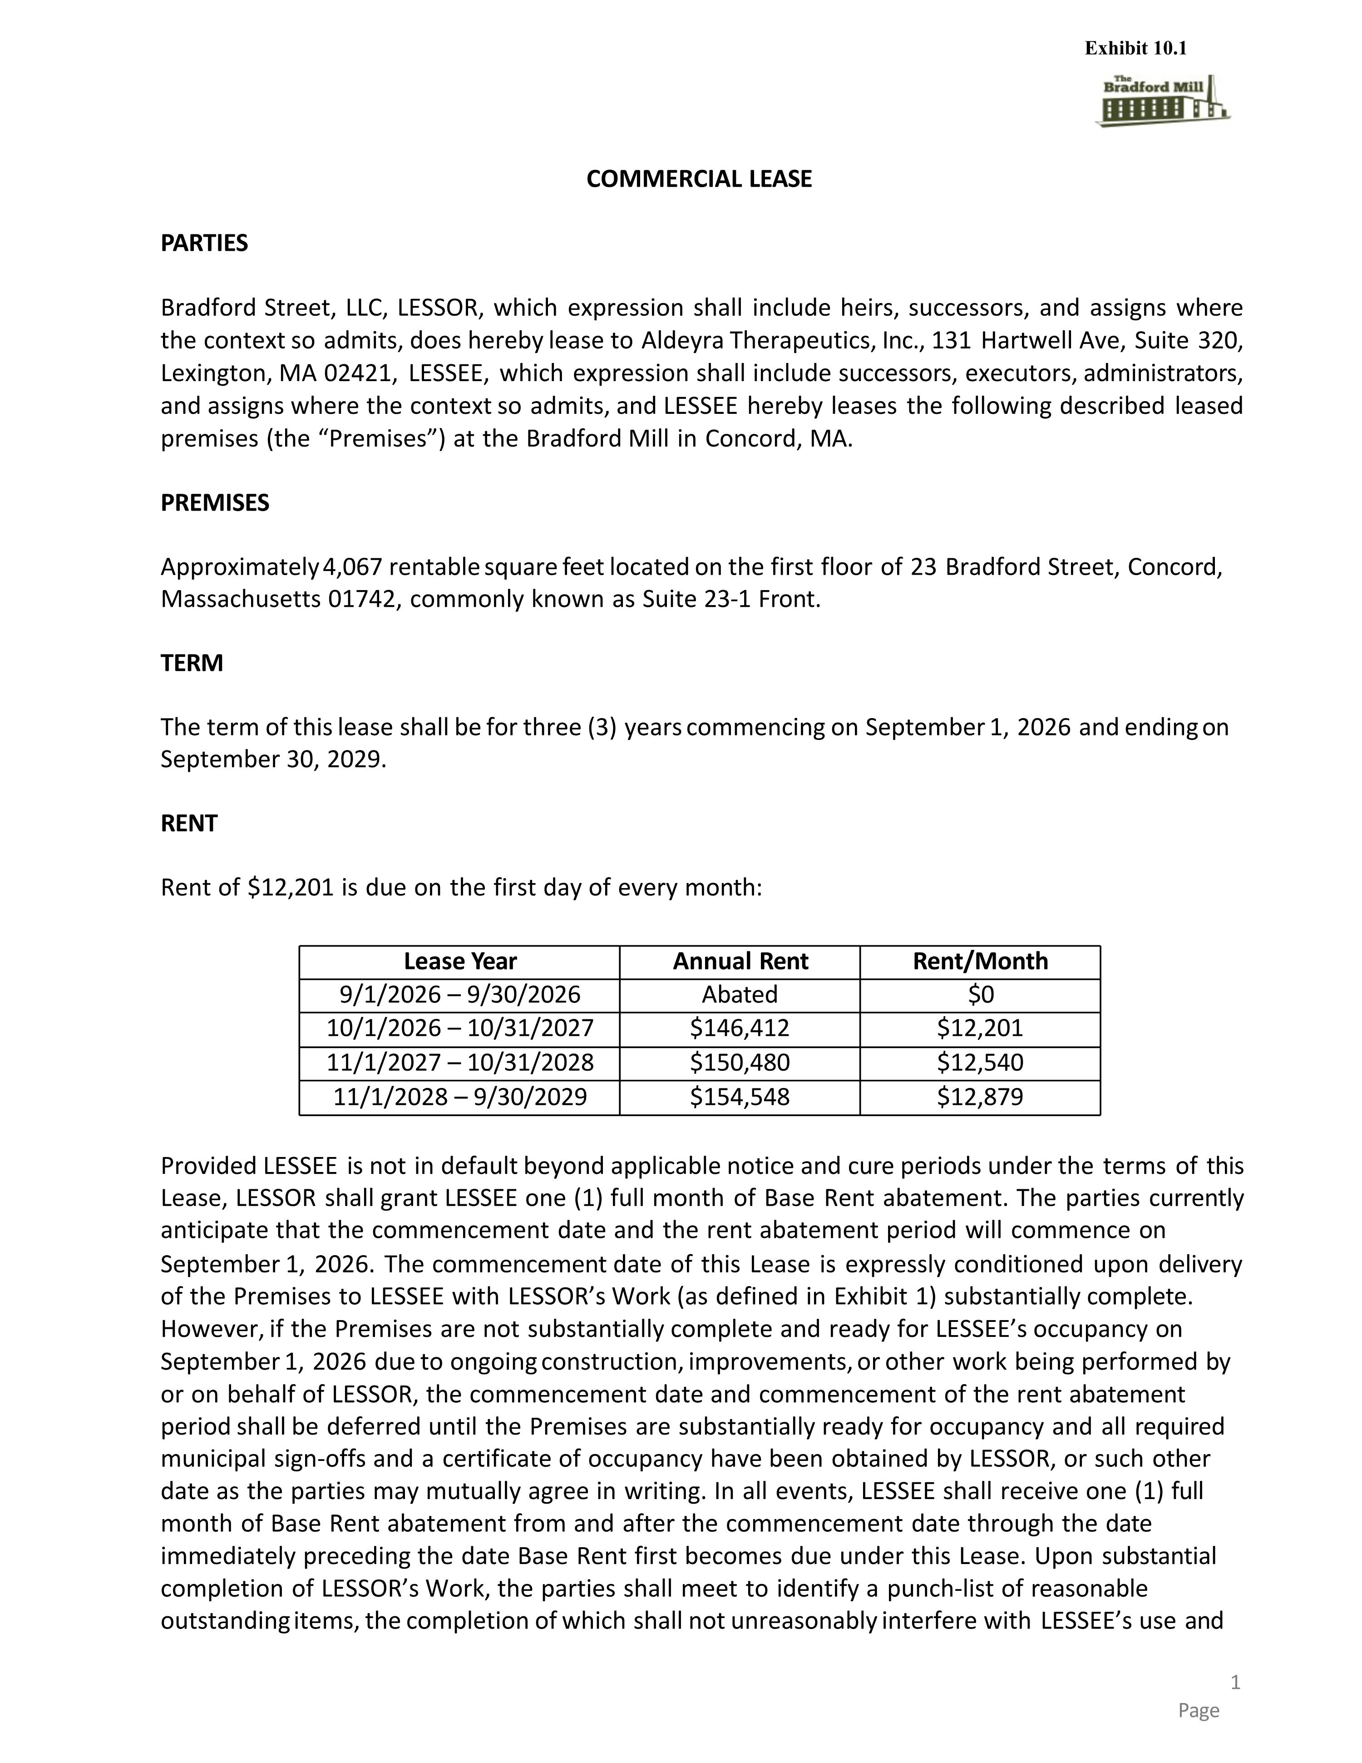
COMMERCIAL LEASE 1 Page PARTIES Bradford Street, LLC, LESSOR, which expression shall include heirs, successors, and assigns where the context so admits, does hereby lease to Aldeyra Therapeutics, Inc., 131 Hartwell Ave, Suite 320, Lexington, MA 02421, LESSEE, which expression shall include successors, executors, administrators, and assigns where the context so admits, and LESSEE hereby leases the following described leased premises (the “Premises”) at the Bradford Mill in Concord, MA. PREMISES Approximately 4,067 rentable square feet located on the first floor of 23 Bradford Street, Concord, Massachusetts 01742, commonly known as Suite 23-1 Front. TERM The term of this lease shall be for three (3) years commencing on September 1, 2026 and ending on September 30, 2029. RENT Rent of $12,201 is due on the first day of every month: Lease Year Annual Rent Rent/Month 9/1/2026 – 9/30/2026 Abated $0 10/1/2026 – 10/31/2027 $146,412 $12,201 11/1/2027 – 10/31/2028 $150,480 $12,540 11/1/2028 – 9/30/2029 $154,548 $12,879 Provided LESSEE is not in default beyond applicable notice and cure periods under the terms of this Lease, LESSOR shall grant LESSEE one (1) full month of Base Rent abatement. The parties currently anticipate that the commencement date and the rent abatement period will commence on September 1, 2026. The commencement date of this Lease is expressly conditioned upon delivery of the Premises to LESSEE with LESSOR’s Work (as defined in Exhibit 1) substantially complete. However, if the Premises are not substantially complete and ready for LESSEE’s occupancy on September 1, 2026 due to ongoing construction, improvements, or other work being performed by or on behalf of LESSOR, the commencement date and commencement of the rent abatement period shall be deferred until the Premises are substantially ready for occupancy and all required municipal sign-offs and a certificate of occupancy have been obtained by LESSOR, or such other date as the parties may mutually agree in writing. In all events, LESSEE shall receive one (1) full month of Base Rent abatement from and after the commencement date through the date immediately preceding the date Base Rent first becomes due under this Lease. Upon substantial completion of LESSOR’s Work, the parties shall meet to identify a punch-list of reasonable outstanding items, the completion of which shall not unreasonably interfere with LESSEE’s use and Exhibit 10.1

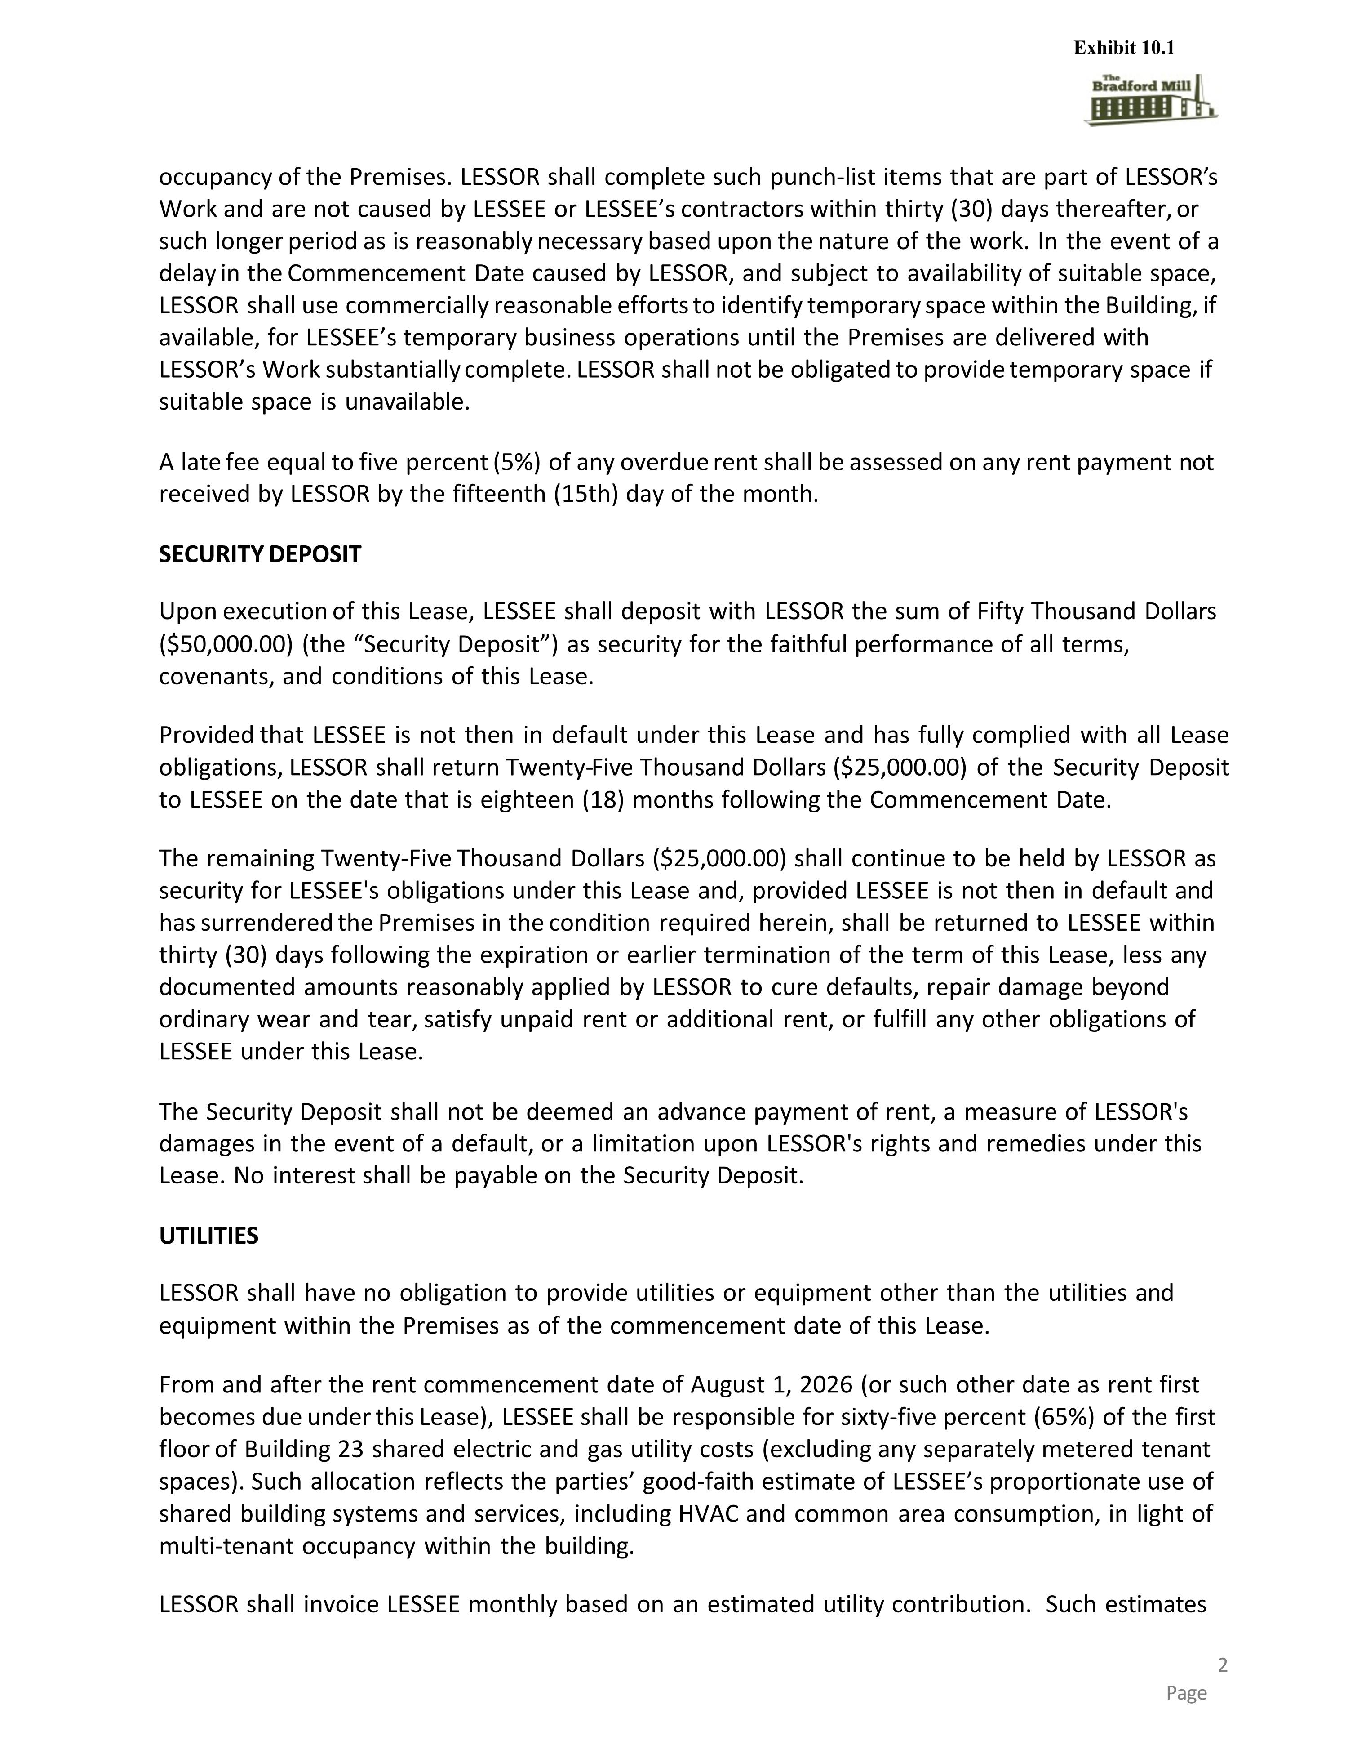
occupancy of the Premises. LESSOR shall complete such punch-list items that are part of LESSOR’s Work and are not caused by LESSEE or LESSEE’s contractors within thirty (30) days thereafter, or such longer period as is reasonably necessary based upon the nature of the work. In the event of a delay in the Commencement Date caused by LESSOR, and subject to availability of suitable space, LESSOR shall use commercially reasonable efforts to identify temporary space within the Building, if available, for LESSEE’s temporary business operations until the Premises are delivered with LESSOR’s Work substantially complete. LESSOR shall not be obligated to provide temporary space if suitable space is unavailable. A late fee equal to five percent (5%) of any overdue rent shall be assessed on any rent payment not received by LESSOR by the fifteenth (15th) day of the month. SECURITY DEPOSIT Upon execution of this Lease, LESSEE shall deposit with LESSOR the sum of Fifty Thousand Dollars ($50,000.00) (the “Security Deposit”) as security for the faithful performance of all terms, covenants, and conditions of this Lease. Provided that LESSEE is not then in default under this Lease and has fully complied with all Lease obligations, LESSOR shall return Twenty-Five Thousand Dollars ($25,000.00) of the Security Deposit to LESSEE on the date that is eighteen (18) months following the Commencement Date. The remaining Twenty-Five Thousand Dollars ($25,000.00) shall continue to be held by LESSOR as security for LESSEE's obligations under this Lease and, provided LESSEE is not then in default and has surrendered the Premises in the condition required herein, shall be returned to LESSEE within thirty (30) days following the expiration or earlier termination of the term of this Lease, less any documented amounts reasonably applied by LESSOR to cure defaults, repair damage beyond ordinary wear and tear, satisfy unpaid rent or additional rent, or fulfill any other obligations of LESSEE under this Lease. The Security Deposit shall not be deemed an advance payment of rent, a measure of LESSOR's damages in the event of a default, or a limitation upon LESSOR's rights and remedies under this Lease. No interest shall be payable on the Security Deposit. UTILITIES LESSOR shall have no obligation to provide utilities or equipment other than the utilities and equipment within the Premises as of the commencement date of this Lease. From and after the rent commencement date of August 1, 2026 (or such other date as rent first becomes due under this Lease), LESSEE shall be responsible for sixty-five percent (65%) of the first floor of Building 23 shared electric and gas utility costs (excluding any separately metered tenant spaces). Such allocation reflects the parties’ good-faith estimate of LESSEE’s proportionate use of shared building systems and services, including HVAC and common area consumption, in light of multi-tenant occupancy within the building. LESSOR shall invoice LESSEE monthly based on an estimated utility contribution. Such estimates 2 Page Exhibit 10.1

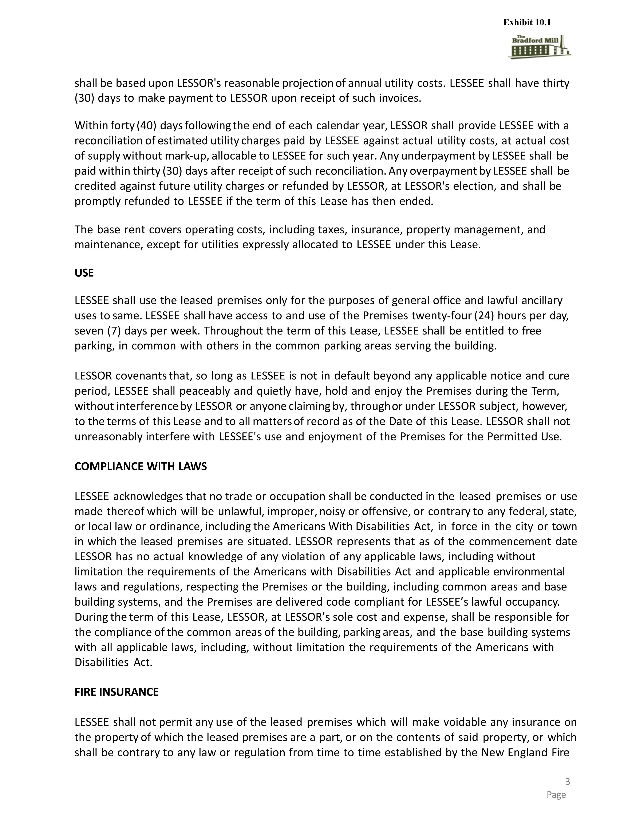
shall be based upon LESSOR's reasonable projection of annual utility costs. LESSEE shall have thirty (30) days to make payment to LESSOR upon receipt of such invoices. Within forty (40) days following the end of each calendar year, LESSOR shall provide LESSEE with a reconciliation of estimated utility charges paid by LESSEE against actual utility costs, at actual cost of supply without mark-up, allocable to LESSEE for such year. Any underpayment by LESSEE shall be paid within thirty (30) days after receipt of such reconciliation. Any overpayment by LESSEE shall be credited against future utility charges or refunded by LESSOR, at LESSOR's election, and shall be promptly refunded to LESSEE if the term of this Lease has then ended. The base rent covers operating costs, including taxes, insurance, property management, and maintenance, except for utilities expressly allocated to LESSEE under this Lease. USE LESSEE shall use the leased premises only for the purposes of general office and lawful ancillary uses to same. LESSEE shall have access to and use of the Premises twenty-four (24) hours per day, seven (7) days per week. Throughout the term of this Lease, LESSEE shall be entitled to free parking, in common with others in the common parking areas serving the building. LESSOR covenants that, so long as LESSEE is not in default beyond any applicable notice and cure period, LESSEE shall peaceably and quietly have, hold and enjoy the Premises during the Term, without interference by LESSOR or anyone claiming by, through or under LESSOR subject, however, to the terms of this Lease and to all matters of record as of the Date of this Lease. LESSOR shall not unreasonably interfere with LESSEE's use and enjoyment of the Premises for the Permitted Use. COMPLIANCE WITH LAWS LESSEE acknowledges that no trade or occupation shall be conducted in the leased premises or use made thereof which will be unlawful, improper, noisy or offensive, or contrary to any federal, state, or local law or ordinance, including the Americans With Disabilities Act, in force in the city or town in which the leased premises are situated. LESSOR represents that as of the commencement date LESSOR has no actual knowledge of any violation of any applicable laws, including without limitation the requirements of the Americans with Disabilities Act and applicable environmental laws and regulations, respecting the Premises or the building, including common areas and base building systems, and the Premises are delivered code compliant for LESSEE’s lawful occupancy. During the term of this Lease, LESSOR, at LESSOR’s sole cost and expense, shall be responsible for the compliance of the common areas of the building, parking areas, and the base building systems with all applicable laws, including, without limitation the requirements of the Americans with Disabilities Act. FIRE INSURANCE LESSEE shall not permit any use of the leased premises which will make voidable any insurance on the property of which the leased premises are a part, or on the contents of said property, or which shall be contrary to any law or regulation from time to time established by the New England Fire Exhibit 10.1

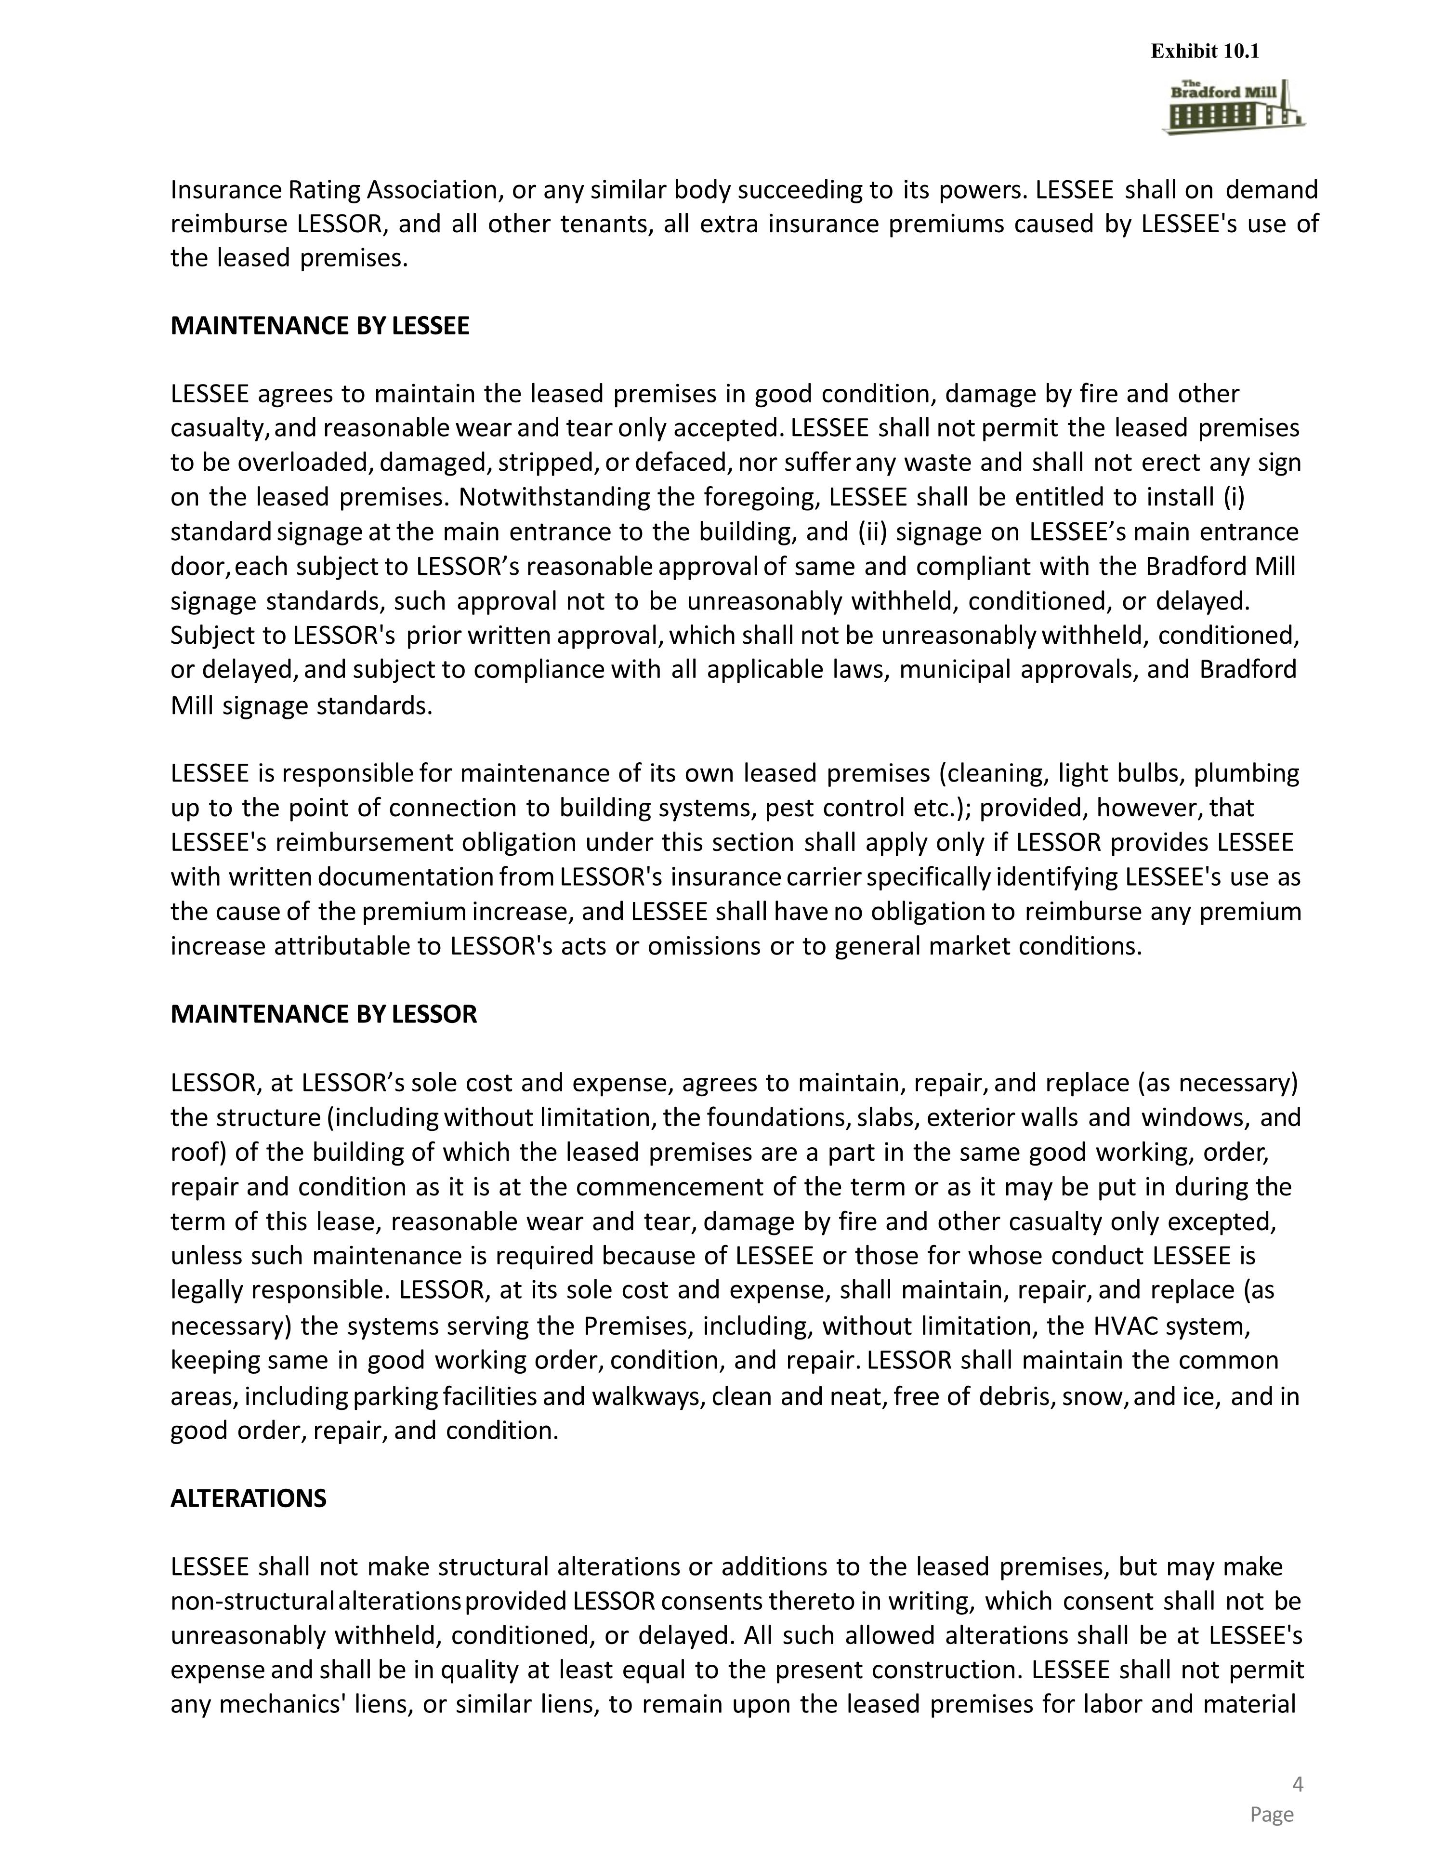
Insurance Rating Association, or any similar body succeeding to its powers. LESSEE shall on demand reimburse LESSOR, and all other tenants, all extra insurance premiums caused by LESSEE's use of the leased premises. MAINTENANCE BY LESSEE LESSEE agrees to maintain the leased premises in good condition, damage by fire and other casualty, and reasonable wear and tear only accepted. LESSEE shall not permit the leased premises to be overloaded, damaged, stripped, or defaced, nor suffer any waste and shall not erect any sign on the leased premises. Notwithstanding the foregoing, LESSEE shall be entitled to install (i) standard signage at the main entrance to the building, and (ii) signage on LESSEE’s main entrance door, each subject to LESSOR’s reasonable approval of same and compliant with the Bradford Mill signage standards, such approval not to be unreasonably withheld, conditioned, or delayed. Subject to LESSOR's prior written approval, which shall not be unreasonably withheld, conditioned, or delayed, and subject to compliance with all applicable laws, municipal approvals, and Bradford Mill signage standards. LESSEE is responsible for maintenance of its own leased premises (cleaning, light bulbs, plumbing up to the point of connection to building systems, pest control etc.); provided, however, that LESSEE's reimbursement obligation under this section shall apply only if LESSOR provides LESSEE with written documentation from LESSOR's insurance carrier specifically identifying LESSEE's use as the cause of the premium increase, and LESSEE shall have no obligation to reimburse any premium increase attributable to LESSOR's acts or omissions or to general market conditions. MAINTENANCE BY LESSOR LESSOR, at LESSOR’s sole cost and expense, agrees to maintain, repair, and replace (as necessary) the structure (including without limitation, the foundations, slabs, exterior walls and windows, and roof) of the building of which the leased premises are a part in the same good working, order, repair and condition as it is at the commencement of the term or as it may be put in during the term of this lease, reasonable wear and tear, damage by fire and other casualty only excepted, unless such maintenance is required because of LESSEE or those for whose conduct LESSEE is legally responsible. LESSOR, at its sole cost and expense, shall maintain, repair, and replace (as necessary) the systems serving the Premises, including, without limitation, the HVAC system, keeping same in good working order, condition, and repair. LESSOR shall maintain the common areas, including parking facilities and walkways, clean and neat, free of debris, snow, and ice, and in good order, repair, and condition. ALTERATIONS LESSEE shall not make structural alterations or additions to the leased premises, but may make non-structural alterations provided LESSOR consents thereto in writing, which consent shall not be unreasonably withheld, conditioned, or delayed. All such allowed alterations shall be at LESSEE's expense and shall be in quality at least equal to the present construction. LESSEE shall not permit any mechanics' liens, or similar liens, to remain upon the leased premises for labor and material Exhibit 10.1

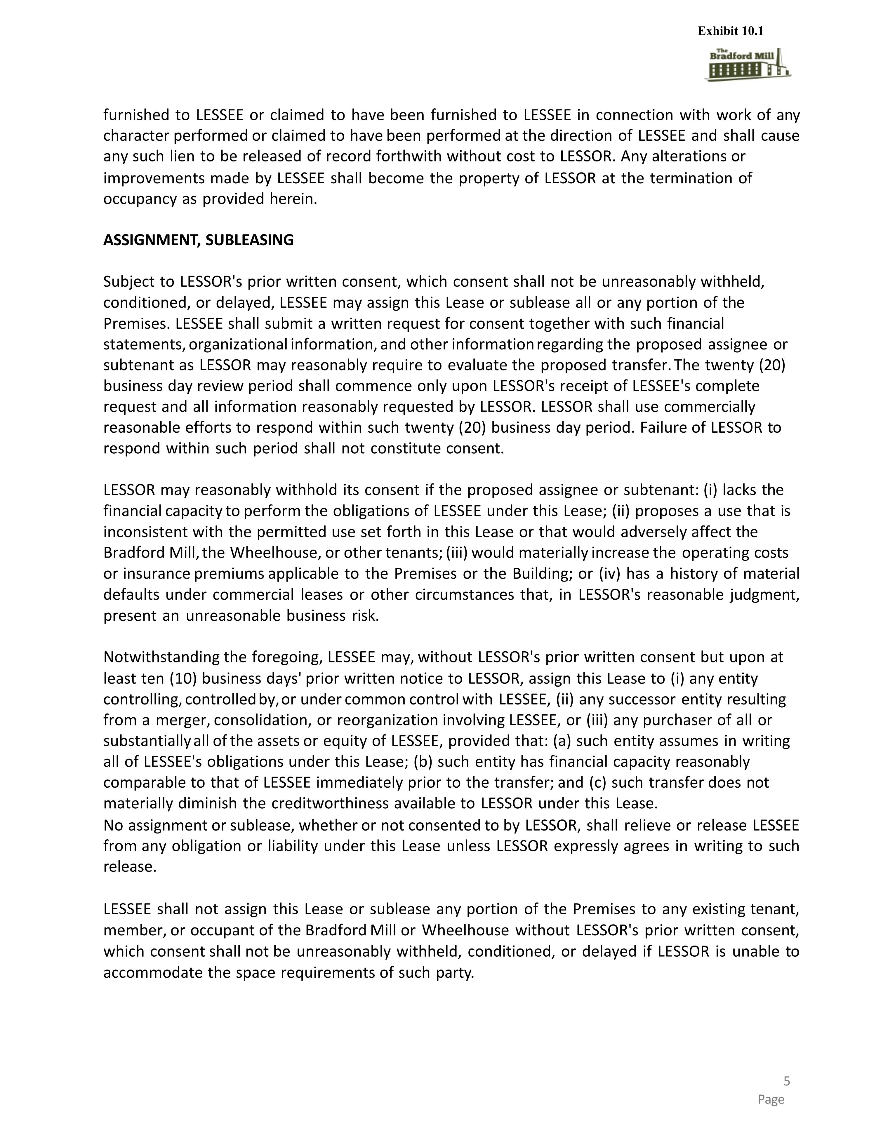
furnished to LESSEE or claimed to have been furnished to LESSEE in connection with work of any character performed or claimed to have been performed at the direction of LESSEE and shall cause any such lien to be released of record forthwith without cost to LESSOR. Any alterations or improvements made by LESSEE shall become the property of LESSOR at the termination of occupancy as provided herein. ASSIGNMENT, SUBLEASING Subject to LESSOR's prior written consent, which consent shall not be unreasonably withheld, conditioned, or delayed, LESSEE may assign this Lease or sublease all or any portion of the Premises. LESSEE shall submit a written request for consent together with such financial statements, organizational information, and other information regarding the proposed assignee or subtenant as LESSOR may reasonably require to evaluate the proposed transfer. The twenty (20) business day review period shall commence only upon LESSOR's receipt of LESSEE's complete request and all information reasonably requested by LESSOR. LESSOR shall use commercially reasonable efforts to respond within such twenty (20) business day period. Failure of LESSOR to respond within such period shall not constitute consent. LESSOR may reasonably withhold its consent if the proposed assignee or subtenant: (i) lacks the financial capacity to perform the obligations of LESSEE under this Lease; (ii) proposes a use that is inconsistent with the permitted use set forth in this Lease or that would adversely affect the Bradford Mill, the Wheelhouse, or other tenants; (iii) would materially increase the operating costs or insurance premiums applicable to the Premises or the Building; or (iv) has a history of material defaults under commercial leases or other circumstances that, in LESSOR's reasonable judgment, present an unreasonable business risk. Notwithstanding the foregoing, LESSEE may, without LESSOR's prior written consent but upon at least ten (10) business days' prior written notice to LESSOR, assign this Lease to (i) any entity controlling, controlled by, or under common control with LESSEE, (ii) any successor entity resulting from a merger, consolidation, or reorganization involving LESSEE, or (iii) any purchaser of all or substantially all of the assets or equity of LESSEE, provided that: (a) such entity assumes in writing all of LESSEE's obligations under this Lease; (b) such entity has financial capacity reasonably comparable to that of LESSEE immediately prior to the transfer; and (c) such transfer does not materially diminish the creditworthiness available to LESSOR under this Lease. No assignment or sublease, whether or not consented to by LESSOR, shall relieve or release LESSEE from any obligation or liability under this Lease unless LESSOR expressly agrees in writing to such release. LESSEE shall not assign this Lease or sublease any portion of the Premises to any existing tenant, member, or occupant of the Bradford Mill or Wheelhouse without LESSOR's prior written consent, which consent shall not be unreasonably withheld, conditioned, or delayed if LESSOR is unable to accommodate the space requirements of such party. Exhibit 10.1

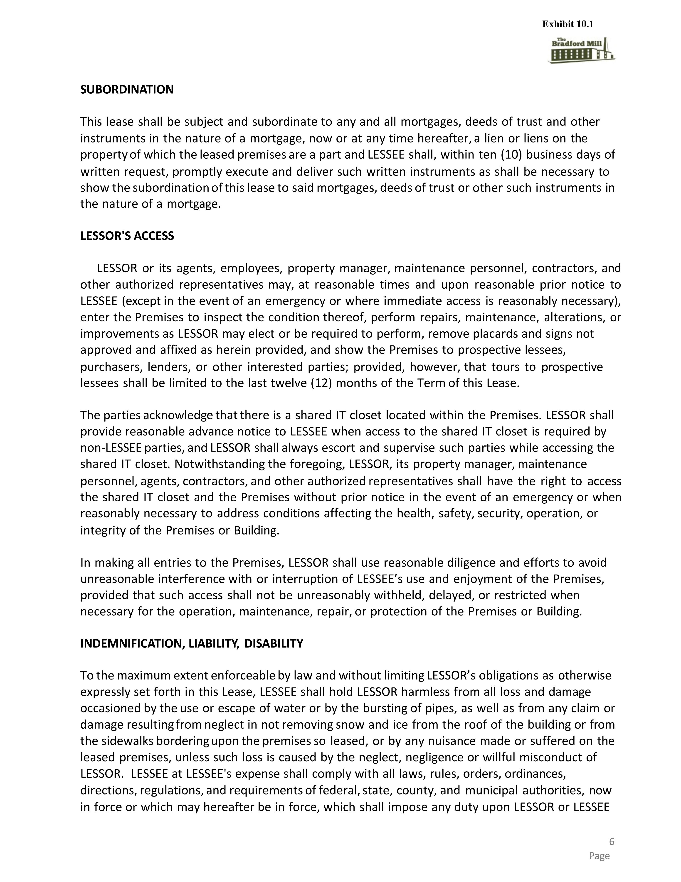
SUBORDINATION This lease shall be subject and subordinate to any and all mortgages, deeds of trust and other instruments in the nature of a mortgage, now or at any time hereafter, a lien or liens on the property of which the leased premises are a part and LESSEE shall, within ten (10) business days of written request, promptly execute and deliver such written instruments as shall be necessary to show the subordination of this lease to said mortgages, deeds of trust or other such instruments in the nature of a mortgage. LESSOR'S ACCESS LESSOR or its agents, employees, property manager, maintenance personnel, contractors, and other authorized representatives may, at reasonable times and upon reasonable prior notice to LESSEE (except in the event of an emergency or where immediate access is reasonably necessary), enter the Premises to inspect the condition thereof, perform repairs, maintenance, alterations, or improvements as LESSOR may elect or be required to perform, remove placards and signs not approved and affixed as herein provided, and show the Premises to prospective lessees, purchasers, lenders, or other interested parties; provided, however, that tours to prospective lessees shall be limited to the last twelve (12) months of the Term of this Lease. The parties acknowledge that there is a shared IT closet located within the Premises. LESSOR shall provide reasonable advance notice to LESSEE when access to the shared IT closet is required by non-LESSEE parties, and LESSOR shall always escort and supervise such parties while accessing the shared IT closet. Notwithstanding the foregoing, LESSOR, its property manager, maintenance personnel, agents, contractors, and other authorized representatives shall have the right to access the shared IT closet and the Premises without prior notice in the event of an emergency or when reasonably necessary to address conditions affecting the health, safety, security, operation, or integrity of the Premises or Building. In making all entries to the Premises, LESSOR shall use reasonable diligence and efforts to avoid unreasonable interference with or interruption of LESSEE’s use and enjoyment of the Premises, provided that such access shall not be unreasonably withheld, delayed, or restricted when necessary for the operation, maintenance, repair, or protection of the Premises or Building. INDEMNIFICATION, LIABILITY, DISABILITY To the maximum extent enforceable by law and without limiting LESSOR’s obligations as otherwise expressly set forth in this Lease, LESSEE shall hold LESSOR harmless from all loss and damage occasioned by the use or escape of water or by the bursting of pipes, as well as from any claim or damage resulting from neglect in not removing snow and ice from the roof of the building or from the sidewalks bordering upon the premises so leased, or by any nuisance made or suffered on the leased premises, unless such loss is caused by the neglect, negligence or willful misconduct of LESSOR. LESSEE at LESSEE's expense shall comply with all laws, rules, orders, ordinances, directions, regulations, and requirements of federal, state, county, and municipal authorities, now in force or which may hereafter be in force, which shall impose any duty upon LESSOR or LESSEE Exhibit 10.1

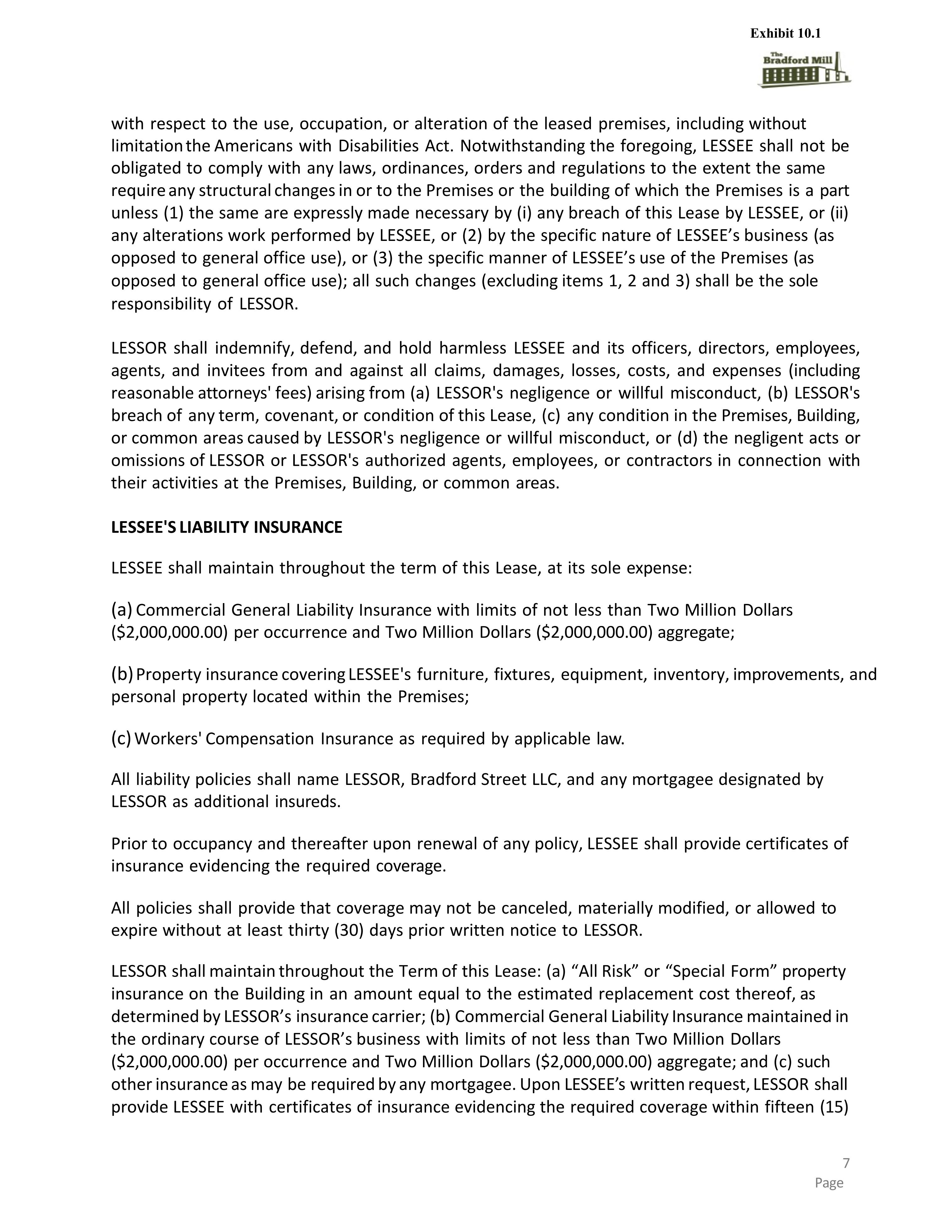
with respect to the use, occupation, or alteration of the leased premises, including without limitation the Americans with Disabilities Act. Notwithstanding the foregoing, LESSEE shall not be obligated to comply with any laws, ordinances, orders and regulations to the extent the same require any structural changes in or to the Premises or the building of which the Premises is a part unless (1) the same are expressly made necessary by (i) any breach of this Lease by LESSEE, or (ii) any alterations work performed by LESSEE, or (2) by the specific nature of LESSEE’s business (as opposed to general office use), or (3) the specific manner of LESSEE’s use of the Premises (as opposed to general office use); all such changes (excluding items 1, 2 and 3) shall be the sole responsibility of LESSOR. LESSOR shall indemnify, defend, and hold harmless LESSEE and its officers, directors, employees, agents, and invitees from and against all claims, damages, losses, costs, and expenses (including reasonable attorneys' fees) arising from (a) LESSOR's negligence or willful misconduct, (b) LESSOR's breach of any term, covenant, or condition of this Lease, (c) any condition in the Premises, Building, or common areas caused by LESSOR's negligence or willful misconduct, or (d) the negligent acts or omissions of LESSOR or LESSOR's authorized agents, employees, or contractors in connection with their activities at the Premises, Building, or common areas. LESSEE'S LIABILITY INSURANCE LESSEE shall maintain throughout the term of this Lease, at its sole expense: Commercial General Liability Insurance with limits of not less than Two Million Dollars ($2,000,000.00) per occurrence and Two Million Dollars ($2,000,000.00) aggregate; Property insurance covering LESSEE's furniture, fixtures, equipment, inventory, improvements, and personal property located within the Premises; Workers' Compensation Insurance as required by applicable law. All liability policies shall name LESSOR, Bradford Street LLC, and any mortgagee designated by LESSOR as additional insureds. Prior to occupancy and thereafter upon renewal of any policy, LESSEE shall provide certificates of insurance evidencing the required coverage. All policies shall provide that coverage may not be canceled, materially modified, or allowed to expire without at least thirty (30) days prior written notice to LESSOR. LESSOR shall maintain throughout the Term of this Lease: (a) “All Risk” or “Special Form” property insurance on the Building in an amount equal to the estimated replacement cost thereof, as determined by LESSOR’s insurance carrier; (b) Commercial General Liability Insurance maintained in the ordinary course of LESSOR’s business with limits of not less than Two Million Dollars ($2,000,000.00) per occurrence and Two Million Dollars ($2,000,000.00) aggregate; and (c) such other insurance as may be required by any mortgagee. Upon LESSEE’s written request, LESSOR shall provide LESSEE with certificates of insurance evidencing the required coverage within fifteen (15) Exhibit 10.1

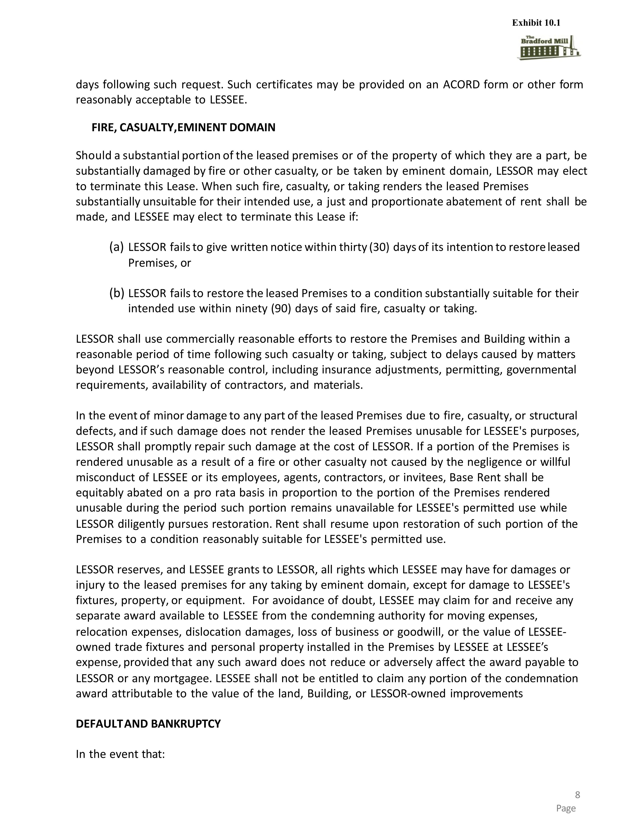
days following such request. Such certificates may be provided on an ACORD form or other form reasonably acceptable to LESSEE. FIRE, CASUALTY, EMINENT DOMAIN Should a substantial portion of the leased premises or of the property of which they are a part, be substantially damaged by fire or other casualty, or be taken by eminent domain, LESSOR may elect to terminate this Lease. When such fire, casualty, or taking renders the leased Premises substantially unsuitable for their intended use, a just and proportionate abatement of rent shall be made, and LESSEE may elect to terminate this Lease if: LESSOR fails to give written notice within thirty (30) days of its intention to restore leased Premises, or LESSOR fails to restore the leased Premises to a condition substantially suitable for their intended use within ninety (90) days of said fire, casualty or taking. LESSOR shall use commercially reasonable efforts to restore the Premises and Building within a reasonable period of time following such casualty or taking, subject to delays caused by matters beyond LESSOR’s reasonable control, including insurance adjustments, permitting, governmental requirements, availability of contractors, and materials. In the event of minor damage to any part of the leased Premises due to fire, casualty, or structural defects, and if such damage does not render the leased Premises unusable for LESSEE's purposes, LESSOR shall promptly repair such damage at the cost of LESSOR. If a portion of the Premises is rendered unusable as a result of a fire or other casualty not caused by the negligence or willful misconduct of LESSEE or its employees, agents, contractors, or invitees, Base Rent shall be equitably abated on a pro rata basis in proportion to the portion of the Premises rendered unusable during the period such portion remains unavailable for LESSEE's permitted use while LESSOR diligently pursues restoration. Rent shall resume upon restoration of such portion of the Premises to a condition reasonably suitable for LESSEE's permitted use. LESSOR reserves, and LESSEE grants to LESSOR, all rights which LESSEE may have for damages or injury to the leased premises for any taking by eminent domain, except for damage to LESSEE's fixtures, property, or equipment. For avoidance of doubt, LESSEE may claim for and receive any separate award available to LESSEE from the condemning authority for moving expenses, relocation expenses, dislocation damages, loss of business or goodwill, or the value of LESSEE-owned trade fixtures and personal property installed in the Premises by LESSEE at LESSEE’s expense, provided that any such award does not reduce or adversely affect the award payable to LESSOR or any mortgagee. LESSEE shall not be entitled to claim any portion of the condemnation award attributable to the value of the land, Building, or LESSOR-owned improvements DEFAULT AND BANKRUPTCY In the event that: Exhibit 10.1

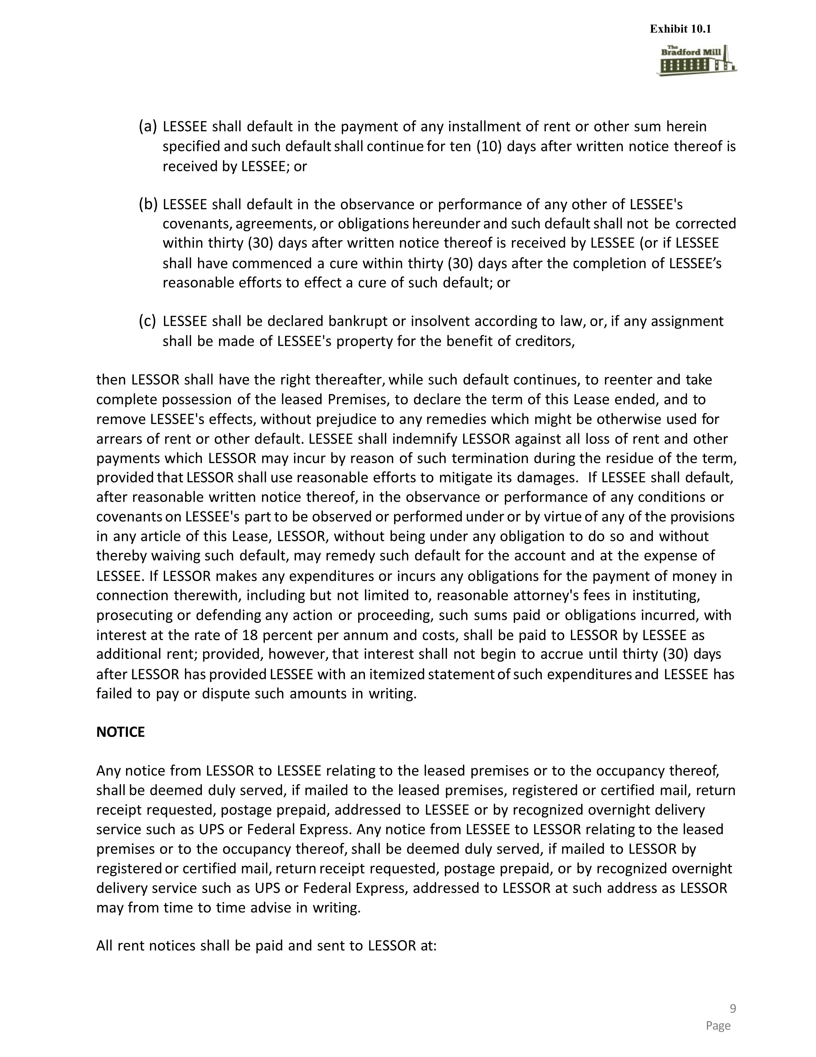
LESSEE shall default in the payment of any installment of rent or other sum herein specified and such default shall continue for ten (10) days after written notice thereof is received by LESSEE; or LESSEE shall default in the observance or performance of any other of LESSEE's covenants, agreements, or obligations hereunder and such default shall not be corrected within thirty (30) days after written notice thereof is received by LESSEE (or if LESSEE shall have commenced a cure within thirty (30) days after the completion of LESSEE’s reasonable efforts to effect a cure of such default; or LESSEE shall be declared bankrupt or insolvent according to law, or, if any assignment shall be made of LESSEE's property for the benefit of creditors, then LESSOR shall have the right thereafter, while such default continues, to reenter and take complete possession of the leased Premises, to declare the term of this Lease ended, and to remove LESSEE's effects, without prejudice to any remedies which might be otherwise used for arrears of rent or other default. LESSEE shall indemnify LESSOR against all loss of rent and other payments which LESSOR may incur by reason of such termination during the residue of the term, provided that LESSOR shall use reasonable efforts to mitigate its damages. If LESSEE shall default, after reasonable written notice thereof, in the observance or performance of any conditions or covenants on LESSEE's part to be observed or performed under or by virtue of any of the provisions in any article of this Lease, LESSOR, without being under any obligation to do so and without thereby waiving such default, may remedy such default for the account and at the expense of LESSEE. If LESSOR makes any expenditures or incurs any obligations for the payment of money in connection therewith, including but not limited to, reasonable attorney's fees in instituting, prosecuting or defending any action or proceeding, such sums paid or obligations incurred, with interest at the rate of 18 percent per annum and costs, shall be paid to LESSOR by LESSEE as additional rent; provided, however, that interest shall not begin to accrue until thirty (30) days after LESSOR has provided LESSEE with an itemized statement of such expenditures and LESSEE has failed to pay or dispute such amounts in writing. NOTICE Any notice from LESSOR to LESSEE relating to the leased premises or to the occupancy thereof, shall be deemed duly served, if mailed to the leased premises, registered or certified mail, return receipt requested, postage prepaid, addressed to LESSEE or by recognized overnight delivery service such as UPS or Federal Express. Any notice from LESSEE to LESSOR relating to the leased premises or to the occupancy thereof, shall be deemed duly served, if mailed to LESSOR by registered or certified mail, return receipt requested, postage prepaid, or by recognized overnight delivery service such as UPS or Federal Express, addressed to LESSOR at such address as LESSOR may from time to time advise in writing. All rent notices shall be paid and sent to LESSOR at: Exhibit 10.1

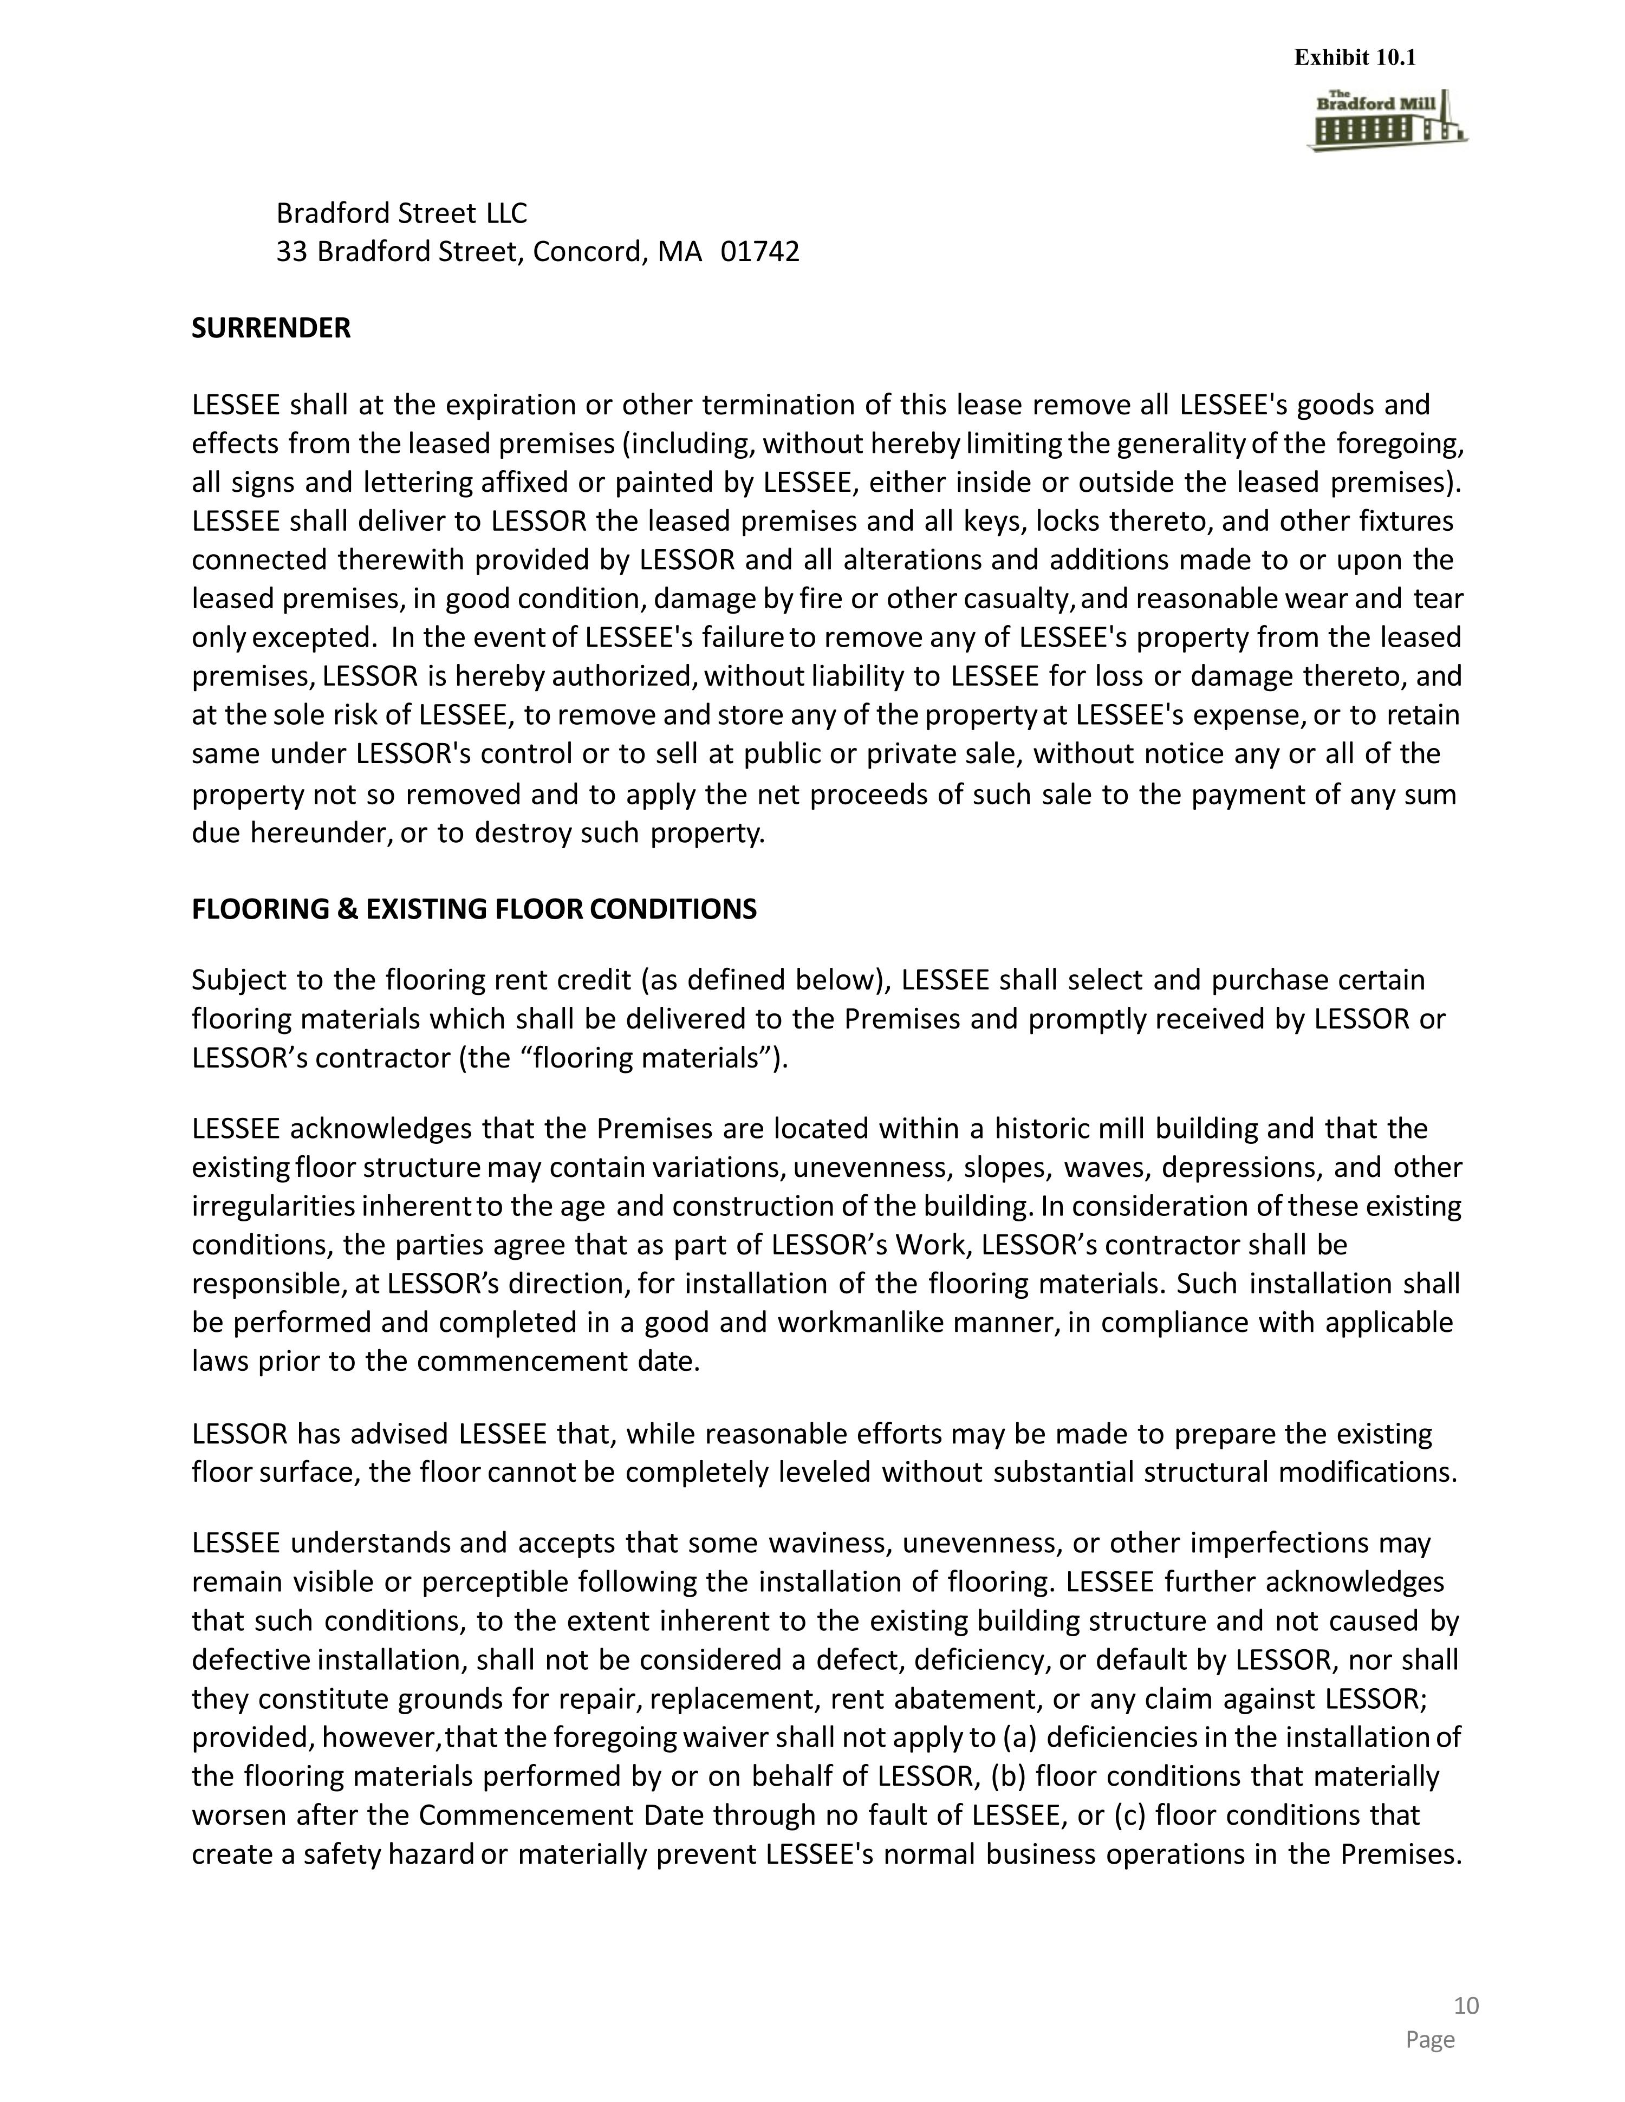
Bradford Street LLC 33 Bradford Street, Concord, MA 01742 SURRENDER LESSEE shall at the expiration or other termination of this lease remove all LESSEE's goods and effects from the leased premises (including, without hereby limiting the generality of the foregoing, all signs and lettering affixed or painted by LESSEE, either inside or outside the leased premises). LESSEE shall deliver to LESSOR the leased premises and all keys, locks thereto, and other fixtures connected therewith provided by LESSOR and all alterations and additions made to or upon the leased premises, in good condition, damage by fire or other casualty, and reasonable wear and tear only excepted. In the event of LESSEE's failure to remove any of LESSEE's property from the leased premises, LESSOR is hereby authorized, without liability to LESSEE for loss or damage thereto, and at the sole risk of LESSEE, to remove and store any of the property at LESSEE's expense, or to retain same under LESSOR's control or to sell at public or private sale, without notice any or all of the property not so removed and to apply the net proceeds of such sale to the payment of any sum due hereunder, or to destroy such property. FLOORING & EXISTING FLOOR CONDITIONS Subject to the flooring rent credit (as defined below), LESSEE shall select and purchase certain flooring materials which shall be delivered to the Premises and promptly received by LESSOR or LESSOR’s contractor (the “flooring materials”). LESSEE acknowledges that the Premises are located within a historic mill building and that the existing floor structure may contain variations, unevenness, slopes, waves, depressions, and other irregularities inherent to the age and construction of the building. In consideration of these existing conditions, the parties agree that as part of LESSOR’s Work, LESSOR’s contractor shall be responsible, at LESSOR’s direction, for installation of the flooring materials. Such installation shall be performed and completed in a good and workmanlike manner, in compliance with applicable laws prior to the commencement date. LESSOR has advised LESSEE that, while reasonable efforts may be made to prepare the existing floor surface, the floor cannot be completely leveled without substantial structural modifications. LESSEE understands and accepts that some waviness, unevenness, or other imperfections may remain visible or perceptible following the installation of flooring. LESSEE further acknowledges that such conditions, to the extent inherent to the existing building structure and not caused by defective installation, shall not be considered a defect, deficiency, or default by LESSOR, nor shall they constitute grounds for repair, replacement, rent abatement, or any claim against LESSOR; provided, however, that the foregoing waiver shall not apply to (a) deficiencies in the installation of the flooring materials performed by or on behalf of LESSOR, (b) floor conditions that materially worsen after the Commencement Date through no fault of LESSEE, or (c) floor conditions that create a safety hazard or materially prevent LESSEE's normal business operations in the Premises. Exhibit 10.1

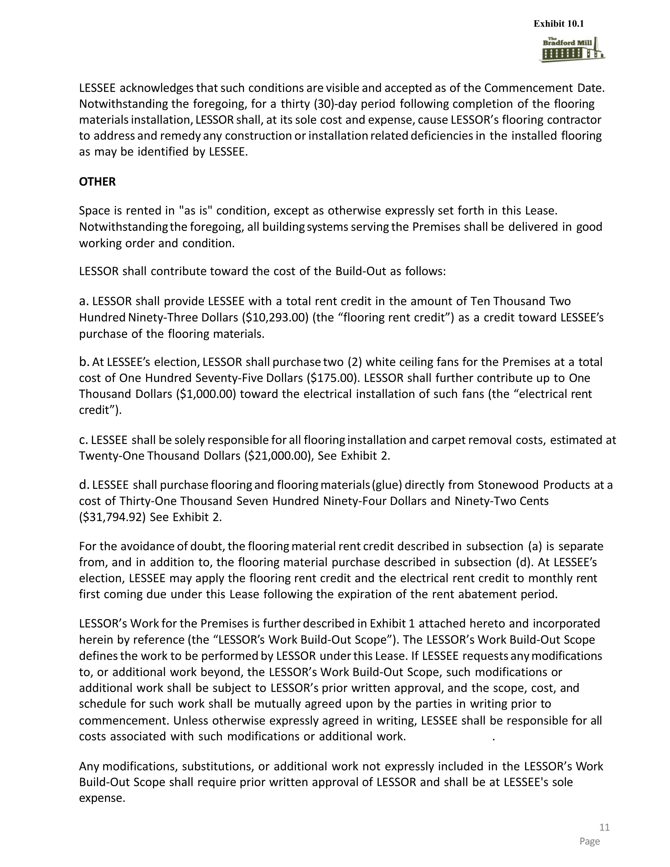
LESSEE acknowledges that such conditions are visible and accepted as of the Commencement Date. Notwithstanding the foregoing, for a thirty (30)-day period following completion of the flooring materials installation, LESSOR shall, at its sole cost and expense, cause LESSOR’s flooring contractor to address and remedy any construction or installation related deficiencies in the installed flooring as may be identified by LESSEE. OTHER Space is rented in "as is" condition, except as otherwise expressly set forth in this Lease. Notwithstanding the foregoing, all building systems serving the Premises shall be delivered in good working order and condition. LESSOR shall contribute toward the cost of the Build-Out as follows: LESSOR shall provide LESSEE with a total rent credit in the amount of Ten Thousand Two Hundred Ninety-Three Dollars ($10,293.00) (the “flooring rent credit”) as a credit toward LESSEE’s purchase of the flooring materials. At LESSEE’s election, LESSOR shall purchase two (2) white ceiling fans for the Premises at a total cost of One Hundred Seventy-Five Dollars ($175.00). LESSOR shall further contribute up to One Thousand Dollars ($1,000.00) toward the electrical installation of such fans (the “electrical rent credit”). LESSEE shall be solely responsible for all flooring installation and carpet removal costs, estimated at Twenty-One Thousand Dollars ($21,000.00), See Exhibit 2. LESSEE shall purchase flooring and flooring materials (glue) directly from Stonewood Products at a cost of Thirty-One Thousand Seven Hundred Ninety-Four Dollars and Ninety-Two Cents ($31,794.92) See Exhibit 2. For the avoidance of doubt, the flooring material rent credit described in subsection (a) is separate from, and in addition to, the flooring material purchase described in subsection (d). At LESSEE’s election, LESSEE may apply the flooring rent credit and the electrical rent credit to monthly rent first coming due under this Lease following the expiration of the rent abatement period. LESSOR’s Work for the Premises is further described in Exhibit 1 attached hereto and incorporated herein by reference (the “LESSOR’s Work Build-Out Scope”). The LESSOR’s Work Build-Out Scope defines the work to be performed by LESSOR under this Lease. If LESSEE requests any modifications to, or additional work beyond, the LESSOR’s Work Build-Out Scope, such modifications or additional work shall be subject to LESSOR’s prior written approval, and the scope, cost, and schedule for such work shall be mutually agreed upon by the parties in writing prior to commencement. Unless otherwise expressly agreed in writing, LESSEE shall be responsible for all costs associated with such modifications or additional work. . Any modifications, substitutions, or additional work not expressly included in the LESSOR’s Work Build-Out Scope shall require prior written approval of LESSOR and shall be at LESSEE's sole expense. Exhibit 10.1

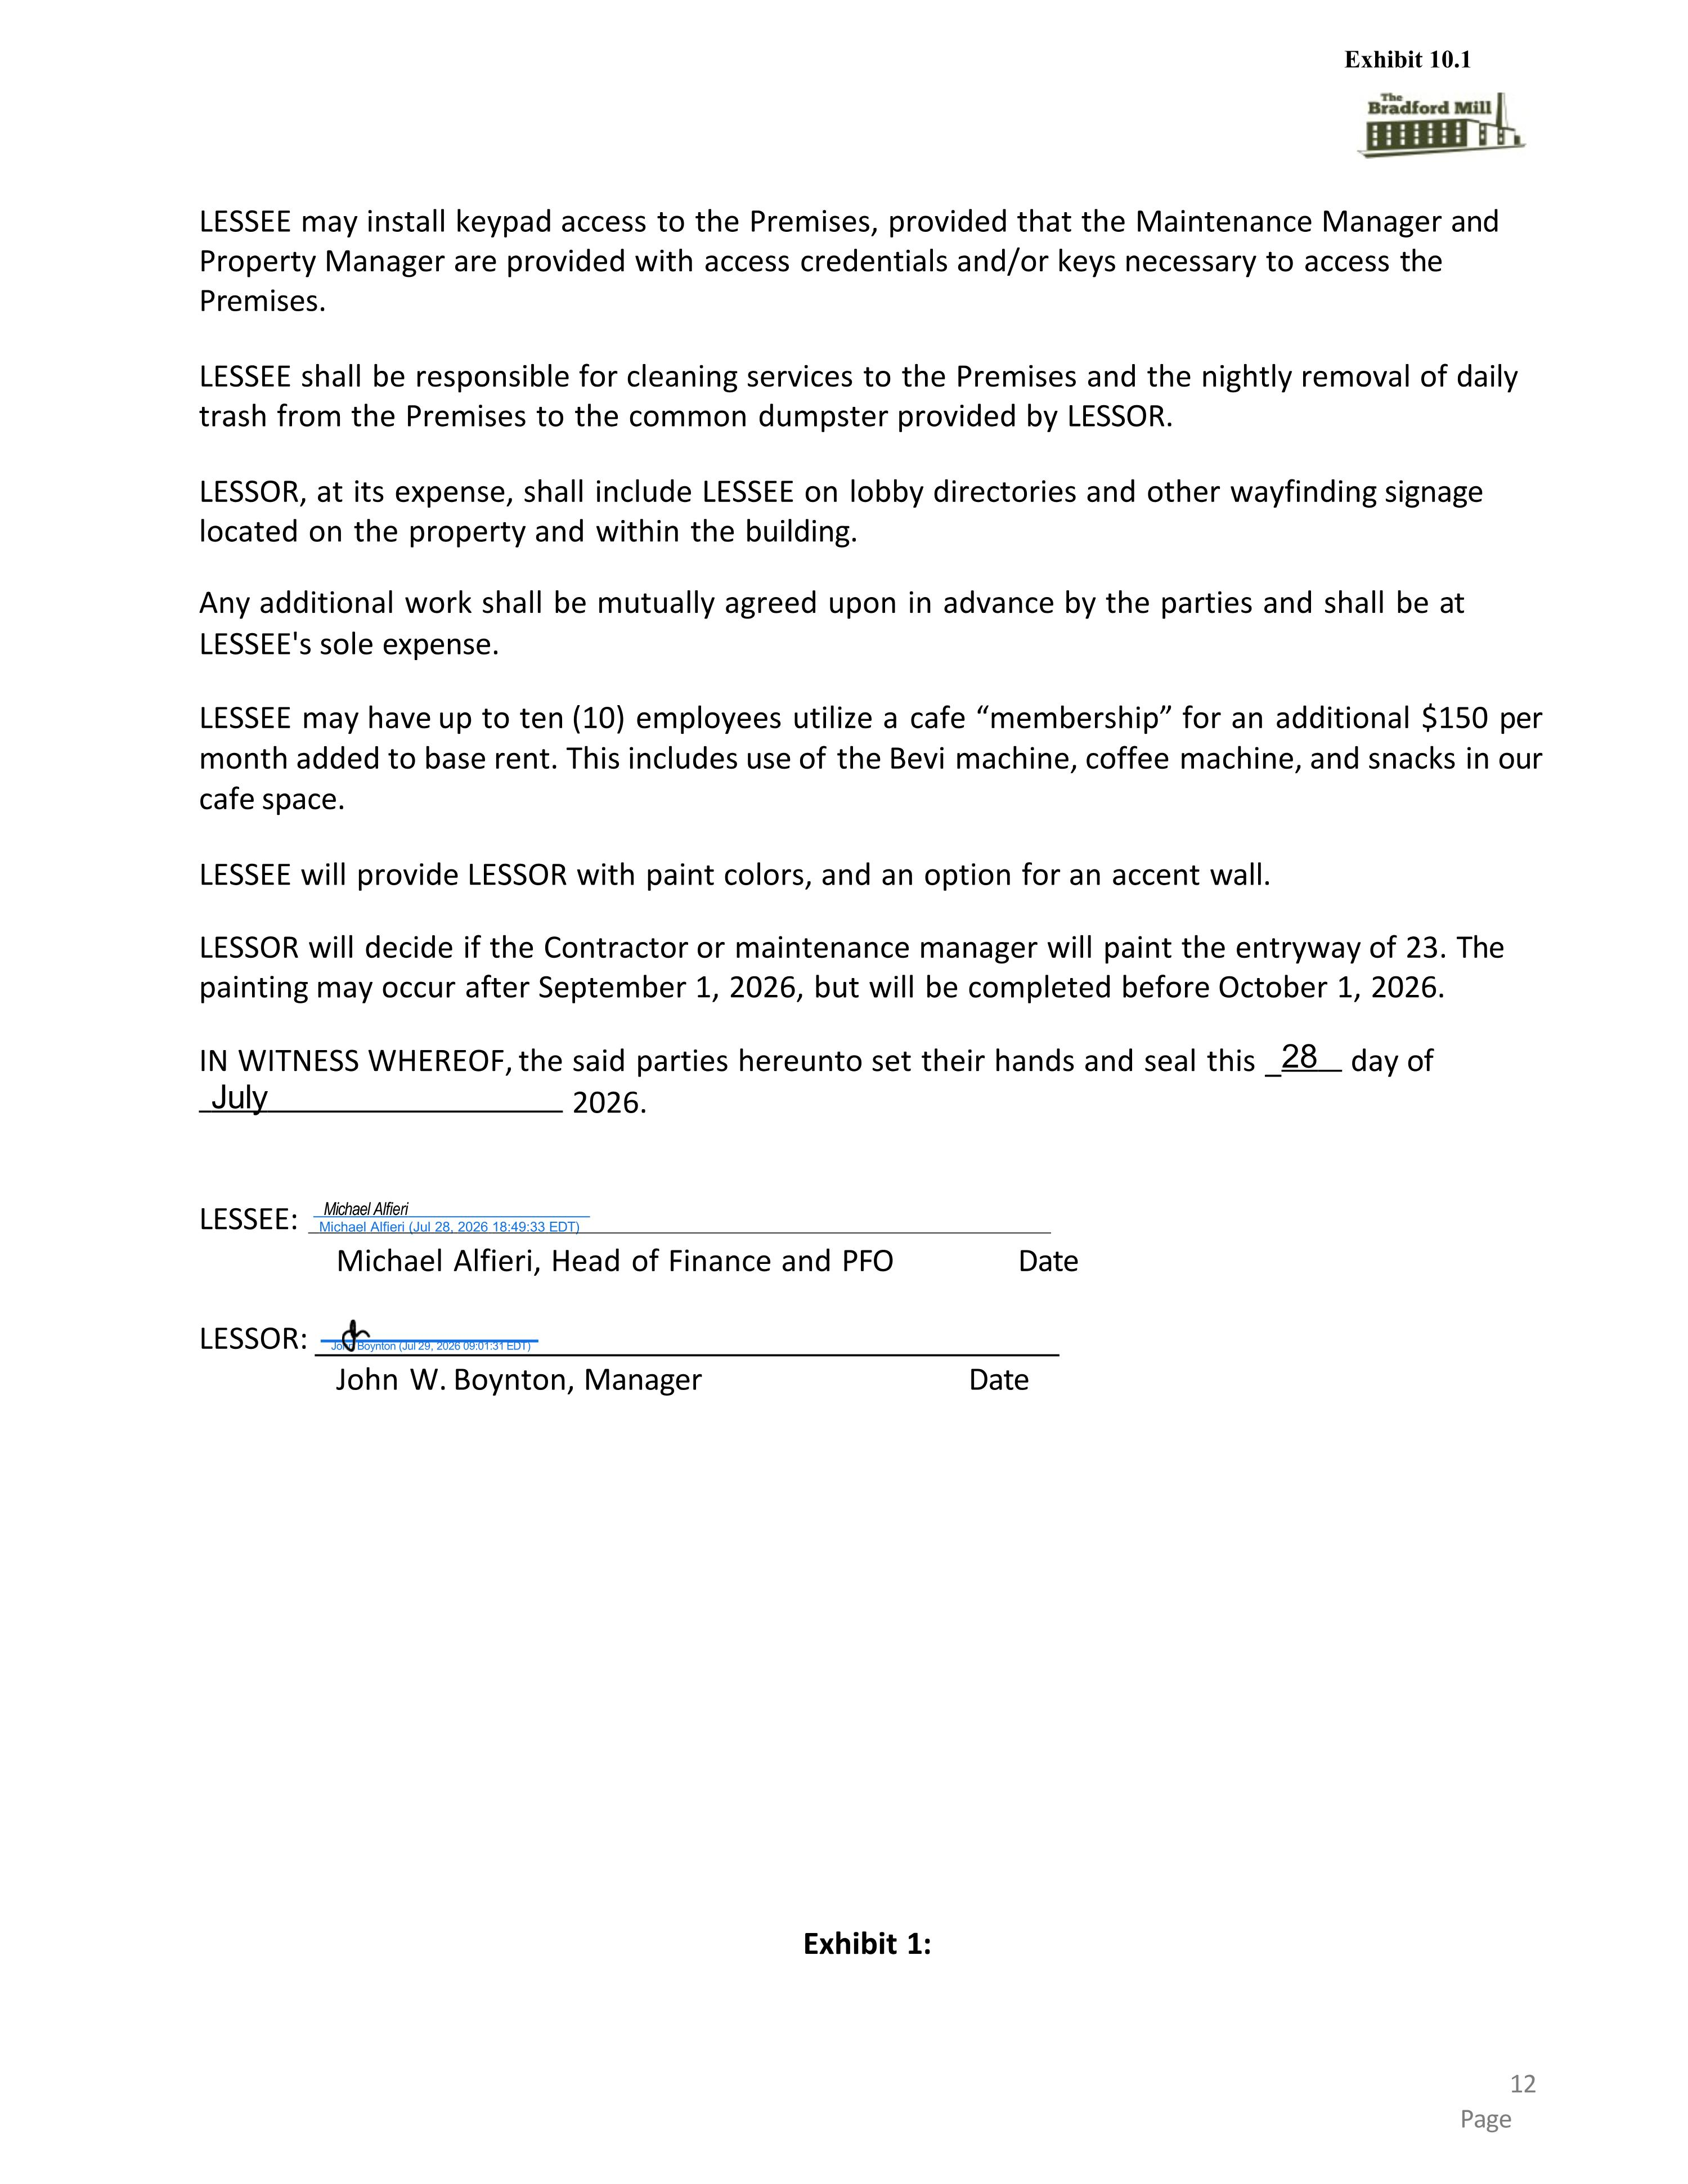
LESSEE may install keypad access to the Premises, provided that the Maintenance Manager and Property Manager are provided with access credentials and/or keys necessary to access the Premises. LESSEE shall be responsible for cleaning services to the Premises and the nightly removal of daily trash from the Premises to the common dumpster provided by LESSOR. LESSOR, at its expense, shall include LESSEE on lobby directories and other wayfinding signage located on the property and within the building. Any additional work shall be mutually agreed upon in advance by the parties and shall be at LESSEE's sole expense. LESSEE may have up to ten (10) employees utilize a cafe “membership” for an additional $150 per month added to base rent. This includes use of the Bevi machine, coffee machine, and snacks in our cafe space. LESSEE will provide LESSOR with paint colors, and an option for an accent wall. LESSOR will decide if the Contractor or maintenance manager will paint the entryway of 23. The painting may occur after September 1, 2026, but will be completed before October 1, 2026. IN WITNESS WHEREOF, the said parties hereunto set their hands and seal this _28 day of July 2026. LESSEE: Michael Alfieri Michael Alfieri (Jul 28, 2026 18:49:33 EDT) Michael Alfieri, Head of Finance and PFO Date John W. Boynton, Manager Date LESSOR: John Boynton (Jul 29, 2026 09:01:31 EDT) Exhibit 1: Exhibit 10.1

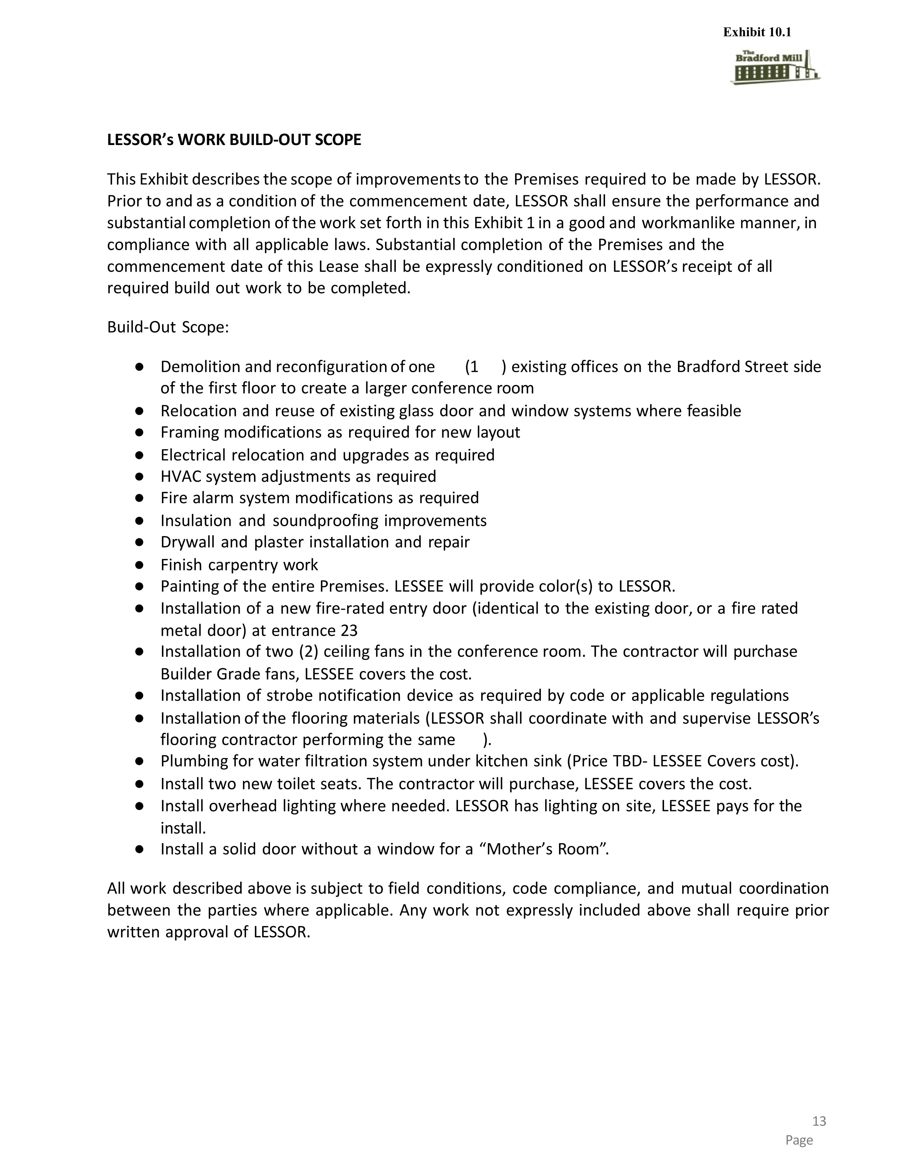
LESSOR’s WORK BUILD-OUT SCOPE This Exhibit describes the scope of improvements to the Premises required to be made by LESSOR. Prior to and as a condition of the commencement date, LESSOR shall ensure the performance and substantial completion of the work set forth in this Exhibit 1 in a good and workmanlike manner, in compliance with all applicable laws. Substantial completion of the Premises and the commencement date of this Lease shall be expressly conditioned on LESSOR’s receipt of all required build out work to be completed. Build-Out Scope: Demolition and reconfiguration of one (1 ) existing offices on the Bradford Street side of the first floor to create a larger conference room Relocation and reuse of existing glass door and window systems where feasible Framing modifications as required for new layout Electrical relocation and upgrades as required HVAC system adjustments as required Fire alarm system modifications as required Insulation and soundproofing improvements Drywall and plaster installation and repair Finish carpentry work Painting of the entire Premises. LESSEE will provide color(s) to LESSOR. Installation of a new fire-rated entry door (identical to the existing door, or a fire rated metal door) at entrance 23 Installation of two (2) ceiling fans in the conference room. The contractor will purchase Builder Grade fans, LESSEE covers the cost. Installation of strobe notification device as required by code or applicable regulations Installation of the flooring materials (LESSOR shall coordinate with and supervise LESSOR’s flooring contractor performing the same ). Plumbing for water filtration system under kitchen sink (Price TBD- LESSEE Covers cost). Install two new toilet seats. The contractor will purchase, LESSEE covers the cost. Install overhead lighting where needed. LESSOR has lighting on site, LESSEE pays for the install. Install a solid door without a window for a “Mother’s Room”. All work described above is subject to field conditions, code compliance, and mutual coordination between the parties where applicable. Any work not expressly included above shall require prior written approval of LESSOR. Exhibit 10.1

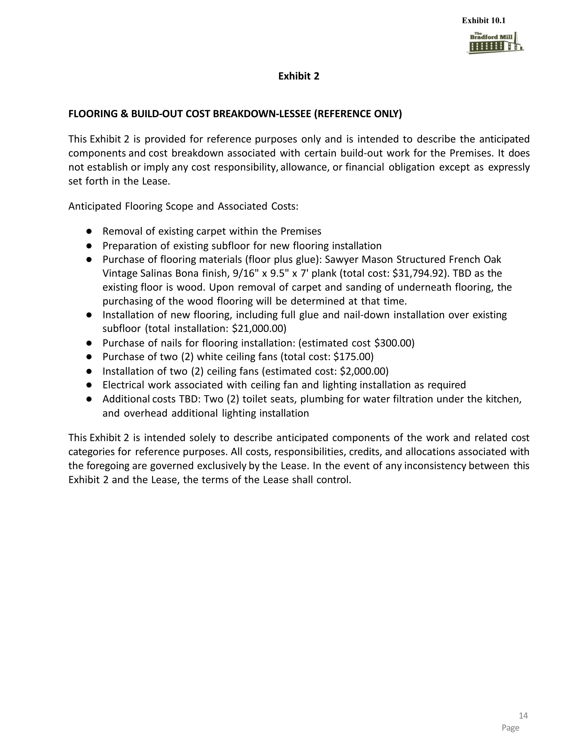
Exhibit 2 FLOORING & BUILD-OUT COST BREAKDOWN-LESSEE (REFERENCE ONLY) This Exhibit 2 is provided for reference purposes only and is intended to describe the anticipated components and cost breakdown associated with certain build-out work for the Premises. It does not establish or imply any cost responsibility, allowance, or financial obligation except as expressly set forth in the Lease. Anticipated Flooring Scope and Associated Costs: Removal of existing carpet within the Premises Preparation of existing subfloor for new flooring installation Purchase of flooring materials (floor plus glue): Sawyer Mason Structured French Oak Vintage Salinas Bona finish, 9/16" x 9.5" x 7' plank (total cost: $31,794.92). TBD as the existing floor is wood. Upon removal of carpet and sanding of underneath flooring, the purchasing of the wood flooring will be determined at that time. Installation of new flooring, including full glue and nail-down installation over existing subfloor (total installation: $21,000.00) Purchase of nails for flooring installation: (estimated cost $300.00) Purchase of two (2) white ceiling fans (total cost: $175.00) Installation of two (2) ceiling fans (estimated cost: $2,000.00) Electrical work associated with ceiling fan and lighting installation as required Additional costs TBD: Two (2) toilet seats, plumbing for water filtration under the kitchen, and overhead additional lighting installation This Exhibit 2 is intended solely to describe anticipated components of the work and related cost categories for reference purposes. All costs, responsibilities, credits, and allocations associated with the foregoing are governed exclusively by the Lease. In the event of any inconsistency between this Exhibit 2 and the Lease, the terms of the Lease shall control. Exhibit 10.1


Exhibit 3 STONEWOOD PRODUCTS QUOTATION (REFERENCE ONLY) Attached hereto and incorporated herein by reference is the Stonewood Products quotation dated June 23, 2026, which is included for pricing reference purposes only and does not modify or expand the obligations of the parties under this Lease. Exhibit 10.1

