UNITED STATES
SECURITIES AND EXCHANGE COMMISSION
Washington, D.C. 20549
FORM 8-K
CURRENT REPORT
Pursuant to Section 13 or 15(d)
of the Securities Exchange Act of 1934
Date of Report (Date of earliest event reported): September 29, 2026
ALDEYRA THERAPEUTICS, INC.
(Exact name of Registrant as specified in its charter)
Delaware |  | 001-36332 |  | 20-1968197
(State or other jurisdiction  of incorporation) |  | (Commission  File No.) |  | (IRS Employer  Identification No.)
23 Bradford Street
Concord, MA 01742
(Address of principal executive offices and zip code)

Registrant’s telephone number, including area code: (781) 761-4904
131 Hartwell Avenue, Suite 320
Lexington, MA 02421
(Former Name or Former Address, if Changed Since Last Report)
Check the appropriate box below if the Form 8-K filing is intended to simultaneously satisfy the filing obligation of the registrant under any of the following provisions:
☐ | Written communications pursuant to Rule 425 under the Securities Act (17 CFR 230.425)
☐ | Soliciting material pursuant to Rule 14a-12 under the Exchange Act (17 CFR 240.14a-12)
☐ | Pre-commencement communications pursuant to Rule 14d-2(b) under the Exchange Act (17 CFR 240.14d-2(b))
☐ | Pre-commencement communications pursuant to Rule 13e-4(c) under the Exchange Act (17 CFR 240.13e-4(c))
Securities registered pursuant to Section 12(b) of the Act:

Title of each class |  | Trading  Symbol(s) |  | Name of each exchange  on which registered
Common Stock, $0.001 par value per share |  | ALDX |  | The Nasdaq Stock Market LLC

Indicate by check mark whether the registrant is an emerging growth company as defined in Rule 405 of the Securities Act of 1933 (§230.405 of this chapter) or Rule 12b-2 of the Securities Exchange Act of 1934 (§240.12b-2 of this chapter).
Emerging growth company ☐
If an emerging growth company, indicate by check mark if the registrant has elected not to use the extended transition period for complying with any new or revised financial accounting standards provided pursuant to Section 13(a) of the Exchange Act. ☐

Item 7.01. | Regulation FD Disclosure.
On September 25, 2026, Aldeyra Therapeutics, Inc. (Aldeyra) held a Type D meeting with the U.S. Food and Drug Administration (FDA) regarding reproxalap for the treatment of dry eye disease. Based on the Type D meeting, on September 29, 2026, Aldeyra issued a press release (the Press Release) announcing the intent to submit a Formal Dispute Resolution Request (FDRR) to the FDA’s Office of New Drugs (OND), appealing the March 16, 2026 Complete Response Letter that denied approval of a New Drug Application for reproxalap for the treatment of dry eye disease, and the extension of Aldeyra’s projected operational cash runway into 2029. The FDRR submission and a meeting with the OND are expected in the fourth quarter of 2026. Aldeyra is holding a conference call regarding the announcement on September 29, 2026. A copy of the supplemental presentation, which will be referenced during the conference call and will be posted on Aldeyra’s website is furnished herewith as Exhibit 99.1 and is incorporated by reference herein.
This information in this Item 7.01 of this Current Report on Form 8-K shall not be deemed “filed” for purposes of Section 18 of the Securities Exchange Act of 1934, as amended (the “Exchange Act”), or otherwise subject to the liabilities of that Section, or incorporated by reference in any filing under the Securities Act of 1933, as amended, or the Exchange Act, except as shall be expressly set forth by specific reference in any such filing.

Item 8.01. | Other Events.

As reported under Item 7.01 of this Current Report on Form 8-K, on September 29, 2026, Aldeyra issued the Press Release to announce the intent to submit an FDRR, appealing the March 16, 2026 Complete Response Letter that denied approval of a New Drug Application for reproxalap for the treatment of dry eye disease, and the extension of Aldeyra’s projected operational cash runway into 2029. The Press Release is filed herewith as Exhibit 99.2 and is incorporated by reference herein.

Forward-Looking Statements
This Current Report on Form 8-K contains and various statements to be made during the conference call are forward-looking statements, including statements regarding the outcome and expected timing of discussions with the FDA; the timing and outcome of the expected FDRR submission; the FDA’s potential approval of reproxalap; the FDA’s potential acceptance and/or approval of a potential NDA resubmission for reproxalap; a potential NDA resubmission or the supplemental responses to the FDA; and Aldeyra’s projected cash runway. Any statements about Aldeyra’s expectations, beliefs, plans, predictions, forecasts, objectives, assumptions, or future events or performance are not historical facts and may be forward-looking. These statements are often, but not always, made through the use of words or phrases such as “anticipates,” “believes,” “can,” “could,” “may,” “predicts,” “potential,” “should,” “will,” “estimate,” “plans,” “projects,” “continuing,” “ongoing,” “expects,” “intends,” and similar words or phrases. Although Aldeyra believes that the expectations reflected in these forward-looking statements are reasonable, these statements are not guarantees of future performance and involve risks and uncertainties which are subject to change based on various important factors, some of which are beyond Aldeyra’s control. Aldeyra has based these forward-looking statements largely on its current expectations and projections about future events and financial trends that it believes may affect its business, financial condition and results of operations. These forward-looking statements speak only as of the date of this Current Report on Form 8-K and are subject to a number of risks, uncertainties and assumptions including, without limitation, risks and factors that are described in the “Risk Factors” and “Management’s Discussion and Analysis of Financial Condition and Results of Operations” sections of Aldeyra’s Annual Report on Form 10-K for the year ended December 31, 2025 and Aldeyra’s Quarterly Report on Form 10-Q for the quarter ended June 30, 2026, which are on file with the SEC and available on the SEC’s website at www.sec.gov. Additional factors may be described in those sections of Aldeyra’s Quarterly Report on Form 10-Q for the quarter ended September 30, 2026, expected to be filed with the SEC in the fourth quarter of 2026.

In addition to the risks described above and in Aldeyra’s other filings with the SEC, other unknown or unpredictable factors also could affect Aldeyra’s results. No forward-looking statements can be guaranteed and actual results may differ materially from such statements. The information conveyed on the conference call is provided only as of the date of the call, and Aldeyra does not undertake any obligation to update any forward-looking statements made in this Current Report on Form 8-K as a result of new information, future events or otherwise.

Item 9.01. | Financial Statements and Exhibits.
(d) Exhibits
Exhibit  No. |  | Description
99.1 |  | Aldeyra Therapeutics, Inc. Presentation dated September 29,2026
99.2 |  | Aldeyra Therapeutics, Inc. Press Release dated September 29,2026
104 |  | Cover Page Interactive Data File (embedded within the Inline XBRL document)

SIGNATURES
Pursuant to the requirements of the Securities Exchange Act of 1934, the registrant has duly caused this report to be signed on its behalf by the undersigned hereunto duly authorized.
ALDEYRA THERAPEUTICS, INC.
By: |  | /s/ Todd C. Brady
Name: |  | Todd C. Brady, M.D., Ph.D.
Title: |  | Chief Executive Officer
Dated September 29, 2026

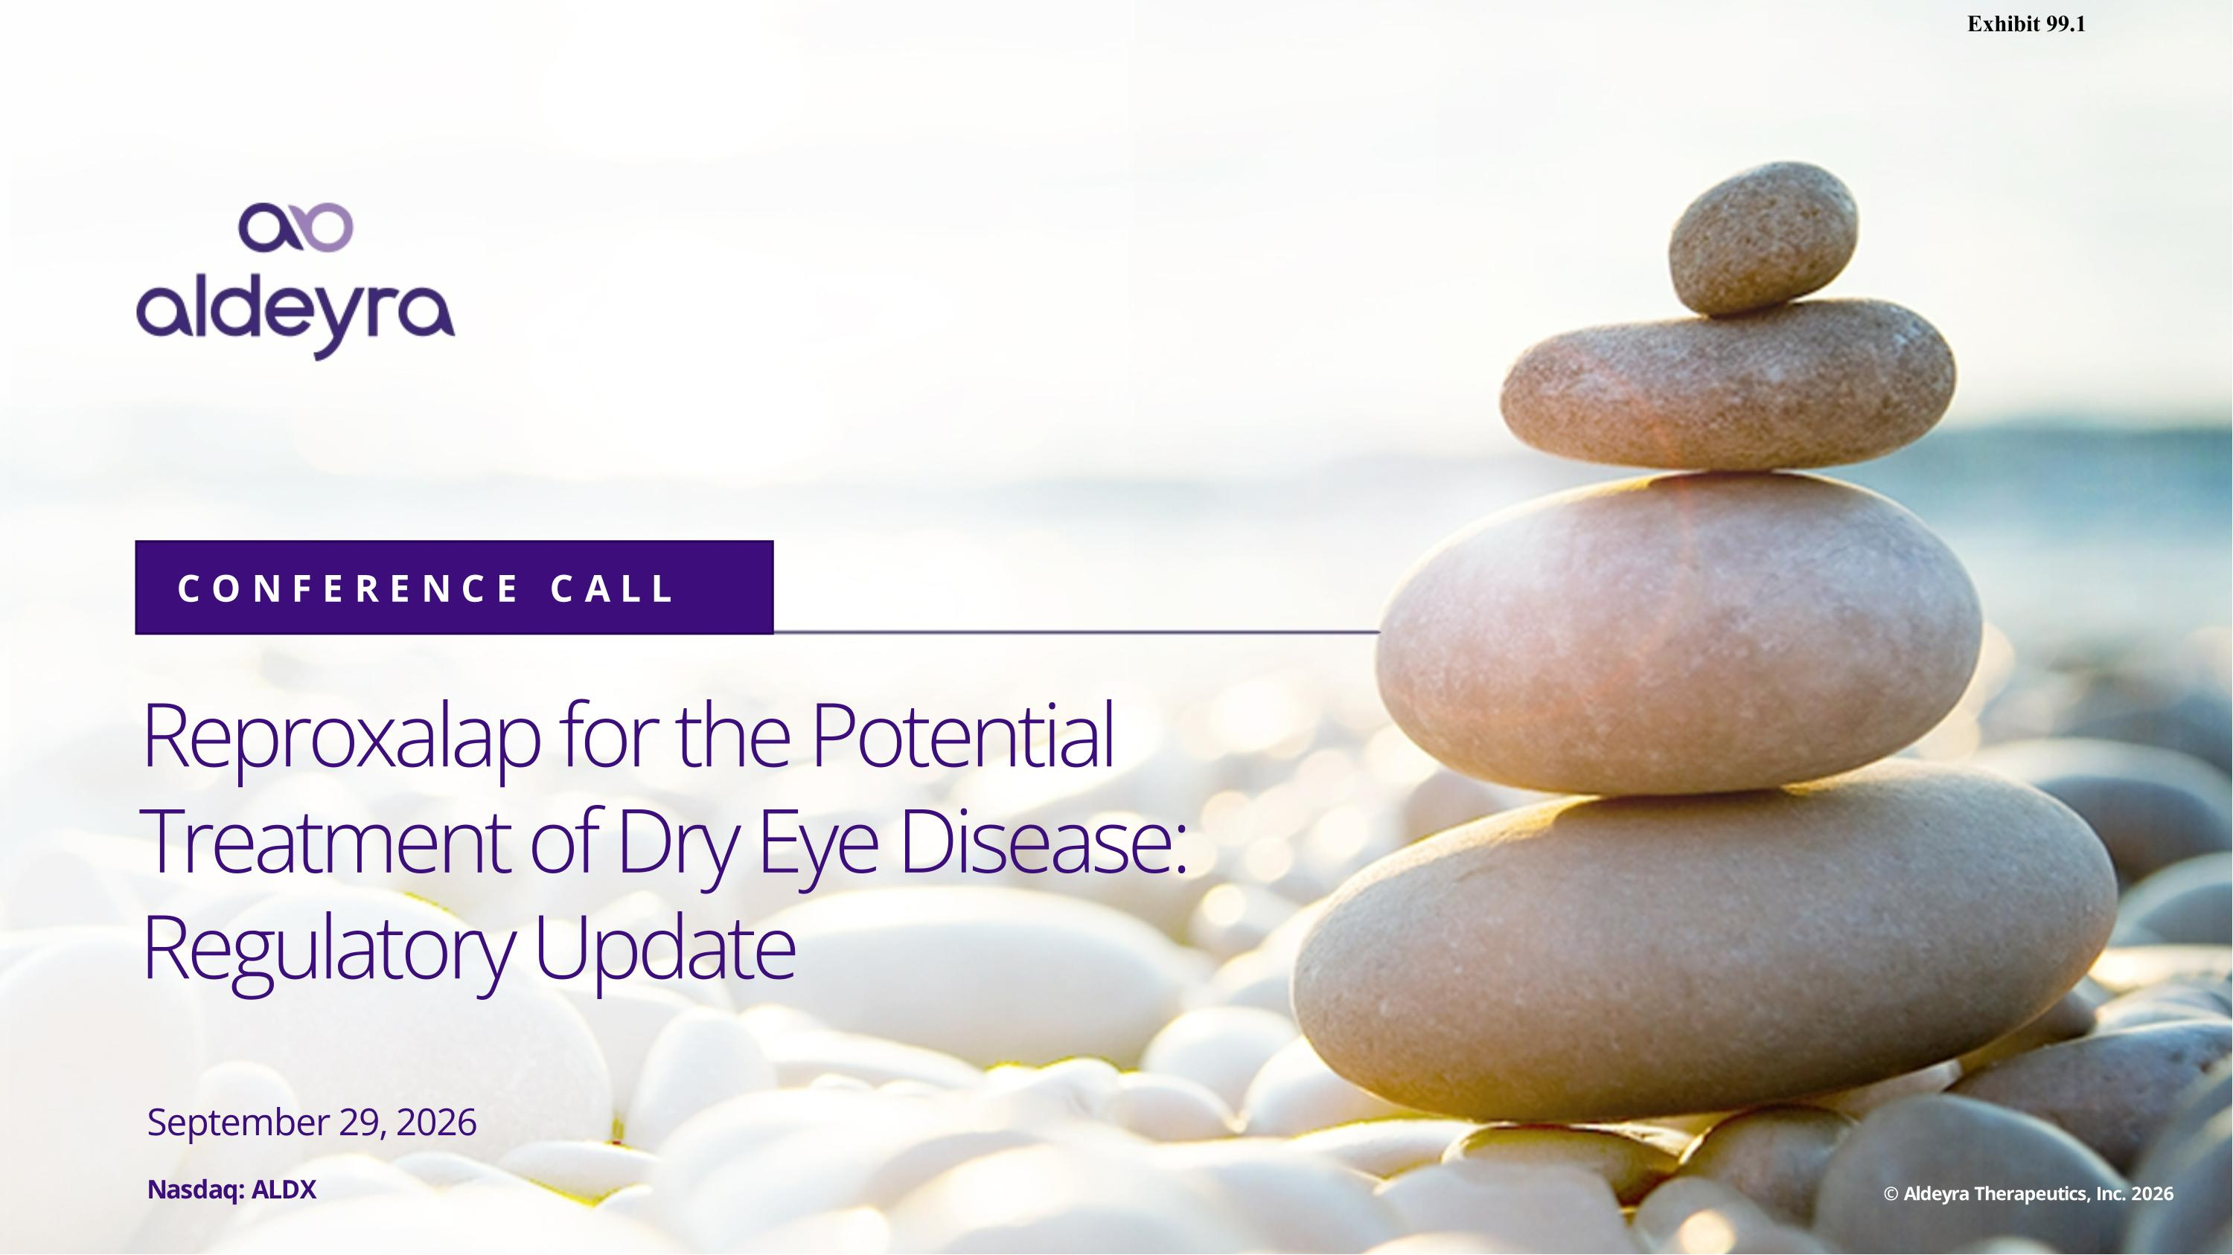
Reproxalap for the Potential Treatment of Dry Eye Disease: Regulatory Update CONFERENCE CALL September 29, 2026 Nasdaq: ALDX © Aldeyra Therapeutics, Inc. 2026 Exhibit 99.1

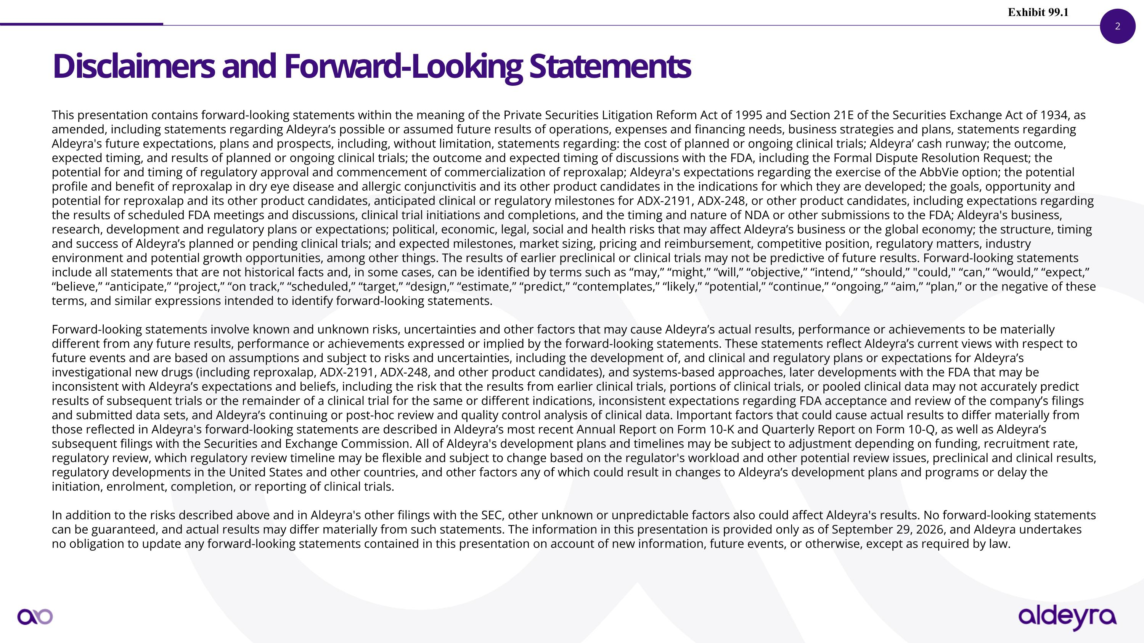
Disclaimers and Forward-Looking Statements This presentation contains forward-looking statements within the meaning of the Private Securities Litigation Reform Act of 1995 and Section 21E of the Securities Exchange Act of 1934, as amended, including statements regarding Aldeyra’s possible or assumed future results of operations, expenses and financing needs, business strategies and plans, statements regarding Aldeyra's future expectations, plans and prospects, including, without limitation, statements regarding: the cost of planned or ongoing clinical trials; Aldeyra’ cash runway; the outcome, expected timing, and results of planned or ongoing clinical trials; the outcome and expected timing of discussions with the FDA, including the Formal Dispute Resolution Request; the potential for and timing of regulatory approval and commencement of commercialization of reproxalap; Aldeyra's expectations regarding the exercise of the AbbVie option; the potential profile and benefit of reproxalap in dry eye disease and allergic conjunctivitis and its other product candidates in the indications for which they are developed; the goals, opportunity and potential for reproxalap and its other product candidates, anticipated clinical or regulatory milestones for ADX-2191, ADX-248, or other product candidates, including expectations regarding the results of scheduled FDA meetings and discussions, clinical trial initiations and completions, and the timing and nature of NDA or other submissions to the FDA; Aldeyra's business, research, development and regulatory plans or expectations; political, economic, legal, social and health risks that may affect Aldeyra’s business or the global economy; the structure, timing and success of Aldeyra’s planned or pending clinical trials; and expected milestones, market sizing, pricing and reimbursement, competitive position, regulatory matters, industry environment and potential growth opportunities, among other things. The results of earlier preclinical or clinical trials may not be predictive of future results. Forward-looking statements include all statements that are not historical facts and, in some cases, can be identified by terms such as “may,” “might,” “will,” “objective,” “intend,” “should,” "could," “can,” “would,” “expect,” “believe,” “anticipate,” “project,” “on track,” “scheduled,” “target,” “design,” “estimate,” “predict,” “contemplates,” “likely,” “potential,” “continue,” “ongoing,” “aim,” “plan,” or the negative of these terms, and similar expressions intended to identify forward-looking statements. Forward-looking statements involve known and unknown risks, uncertainties and other factors that may cause Aldeyra’s actual results, performance or achievements to be materially different from any future results, performance or achievements expressed or implied by the forward-looking statements. These statements reflect Aldeyra’s current views with respect to future events and are based on assumptions and subject to risks and uncertainties, including the development of, and clinical and regulatory plans or expectations for Aldeyra’s investigational new drugs (including reproxalap, ADX-2191, ADX-248, and other product candidates), and systems-based approaches, later developments with the FDA that may be inconsistent with Aldeyra’s expectations and beliefs, including the risk that the results from earlier clinical trials, portions of clinical trials, or pooled clinical data may not accurately predict results of subsequent trials or the remainder of a clinical trial for the same or different indications, inconsistent expectations regarding FDA acceptance and review of the company’s filings and submitted data sets, and Aldeyra’s continuing or post-hoc review and quality control analysis of clinical data. Important factors that could cause actual results to differ materially from those reflected in Aldeyra's forward-looking statements are described in Aldeyra’s most recent Annual Report on Form 10-K and Quarterly Report on Form 10-Q, as well as Aldeyra’s subsequent filings with the Securities and Exchange Commission. All of Aldeyra's development plans and timelines may be subject to adjustment depending on funding, recruitment rate, regulatory review, which regulatory review timeline may be flexible and subject to change based on the regulator's workload and other potential review issues, preclinical and clinical results, regulatory developments in the United States and other countries, and other factors any of which could result in changes to Aldeyra’s development plans and programs or delay the initiation, enrolment, completion, or reporting of clinical trials. In addition to the risks described above and in Aldeyra's other filings with the SEC, other unknown or unpredictable factors also could affect Aldeyra's results. No forward-looking statements can be guaranteed, and actual results may differ materially from such statements. The information in this presentation is provided only as of September 29, 2026, and Aldeyra undertakes no obligation to update any forward-looking statements contained in this presentation on account of new information, future events, or otherwise, except as required by law. Exhibit 99.1

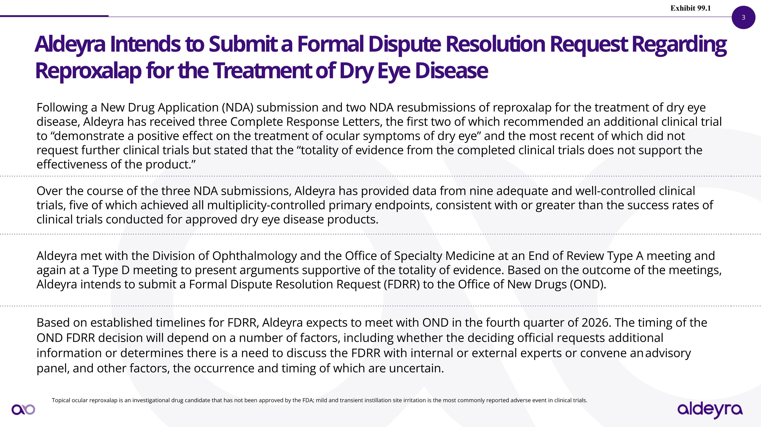
Aldeyra Intends to Submit a Formal Dispute Resolution Request Regarding Reproxalap for the Treatment of Dry Eye Disease Topical ocular reproxalap is an investigational drug candidate that has not been approved by the FDA; mild and transient instillation site irritation is the most commonly reported adverse event in clinical trials. Following a New Drug Application (NDA) submission and two NDA resubmissions of reproxalap for the treatment of dry eye disease, Aldeyra has received three Complete Response Letters, the first two of which recommended an additional clinical trial to “demonstrate a positive effect on the treatment of ocular symptoms of dry eye” and the most recent of which did not request further clinical trials but stated that the “totality of evidence from the completed clinical trials does not support the effectiveness of the product.” Over the course of the three NDA submissions, Aldeyra has provided data from nine adequate and well-controlled clinical trials, five of which achieved all multiplicity-controlled primary endpoints, consistent with or greater than the success rates of clinical trials conducted for approved dry eye disease products. Aldeyra met with the Division of Ophthalmology and the Office of Specialty Medicine at an End of Review Type A meeting and again at a Type D meeting to present arguments supportive of the totality of evidence. Based on the outcome of the meetings, Aldeyra intends to submit a Formal Dispute Resolution Request (FDRR) to the Office of New Drugs (OND). Based on established timelines for FDRR, Aldeyra expects to meet with OND in the fourth quarter of 2026. The timing of the OND FDRR decision will depend on a number of factors, including whether the deciding official requests additional information or determines there is a need to discuss the FDRR with internal or external experts or convene an advisory panel, and other factors, the occurrence and timing of which are uncertain. Exhibit 99.1

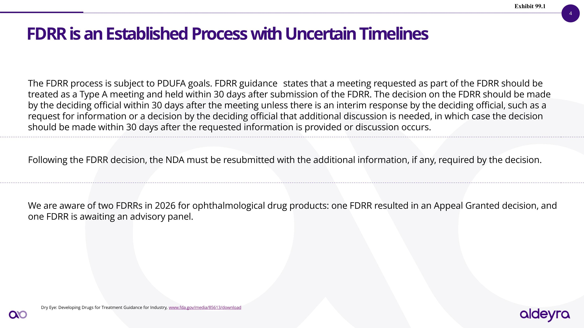
FDRR is an Established Process with Uncertain Timelines Dry Eye: Developing Drugs for Treatment Guidance for Industry, www.fda.gov/media/85613/download The FDRR process is subject to PDUFA goals. FDRR guidance states that a meeting requested as part of the FDRR should be treated as a Type A meeting and held within 30 days after submission of the FDRR. The decision on the FDRR should be made by the deciding official within 30 days after the meeting unless there is an interim response by the deciding official, such as a request for information or a decision by the deciding official that additional discussion is needed, in which case the decision should be made within 30 days after the requested information is provided or discussion occurs. Following the FDRR decision, the NDA must be resubmitted with the additional information, if any, required by the decision. We are aware of two FDRRs in 2026 for ophthalmological drug products: one FDRR resulted in an Appeal Granted decision, and one FDRR is awaiting an advisory panel. Exhibit 99.1

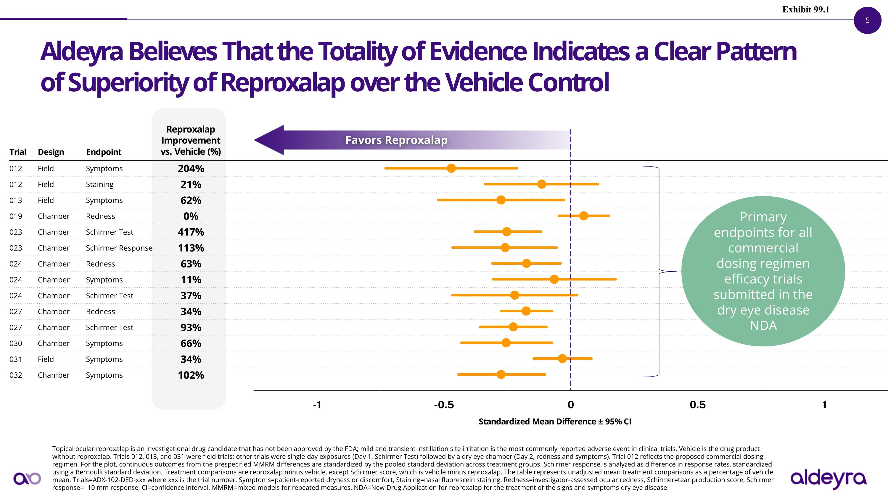
-1 -0.5 0 0.5 1 Aldeyra Believes That the Totality of Evidence Indicates a Clear Pattern of Superiority of Reproxalap over the Vehicle Control Topical ocular reproxalap is an investigational drug candidate that has not been approved by the FDA; mild and transient instillation site irritation is the most commonly reported adverse event in clinical trials. Vehicle is the drug product without reproxalap. Trials 012, 013, and 031 were field trials; other trials were single-day exposures (Day 1, Schirmer Test) followed by a dry eye chamber (Day 2, redness and symptoms). Trial 012 reflects the proposed commercial dosing regimen. For the plot, continuous outcomes from the prespecified MMRM differences are standardized by the pooled standard deviation across treatment groups. Schirmer response is analyzed as difference in response rates, standardized using a Bernoulli standard deviation. Treatment comparisons are reproxalap minus vehicle, except Schirmer score, which is vehicle minus reproxalap. The table represents unadjusted mean treatment comparisons as a percentage of vehicle mean. Trials=ADX-102-DED-xxx where xxx is the trial number, Symptoms=patient-reported dryness or discomfort, Staining=nasal fluorescein staining, Redness=investigator-assessed ocular redness, Schirmer=tear production score, Schirmer response=≥10 mm response, CI=confidence interval, MMRM=mixed models for repeated measures, NDA=New Drug Application for reproxalap for the treatment of the signs and symptoms dry eye disease Trial Design Endpoint Reproxalap Improvement ?vs. Vehicle (%) 012 Field Symptoms 204% 012 Field Staining 21% 013 Field Symptoms 62% 019 Chamber Redness 0% 023 Chamber Schirmer Test 417% 023 Chamber Schirmer Response 113% 024 Chamber Redness 63% 024 Chamber Symptoms 11% 024 Chamber Schirmer Test 37% 027 Chamber Redness 34% 027 Chamber Schirmer Test 93% 030 Chamber Symptoms 66% 031 Field Symptoms 34% 032 Chamber Symptoms 102% Standardized Mean Difference ± 95% CI Favors Reproxalap Primary endpoints for all commercial dosing regimen efficacy trials submitted in the dry eye disease NDA Exhibit 99.1

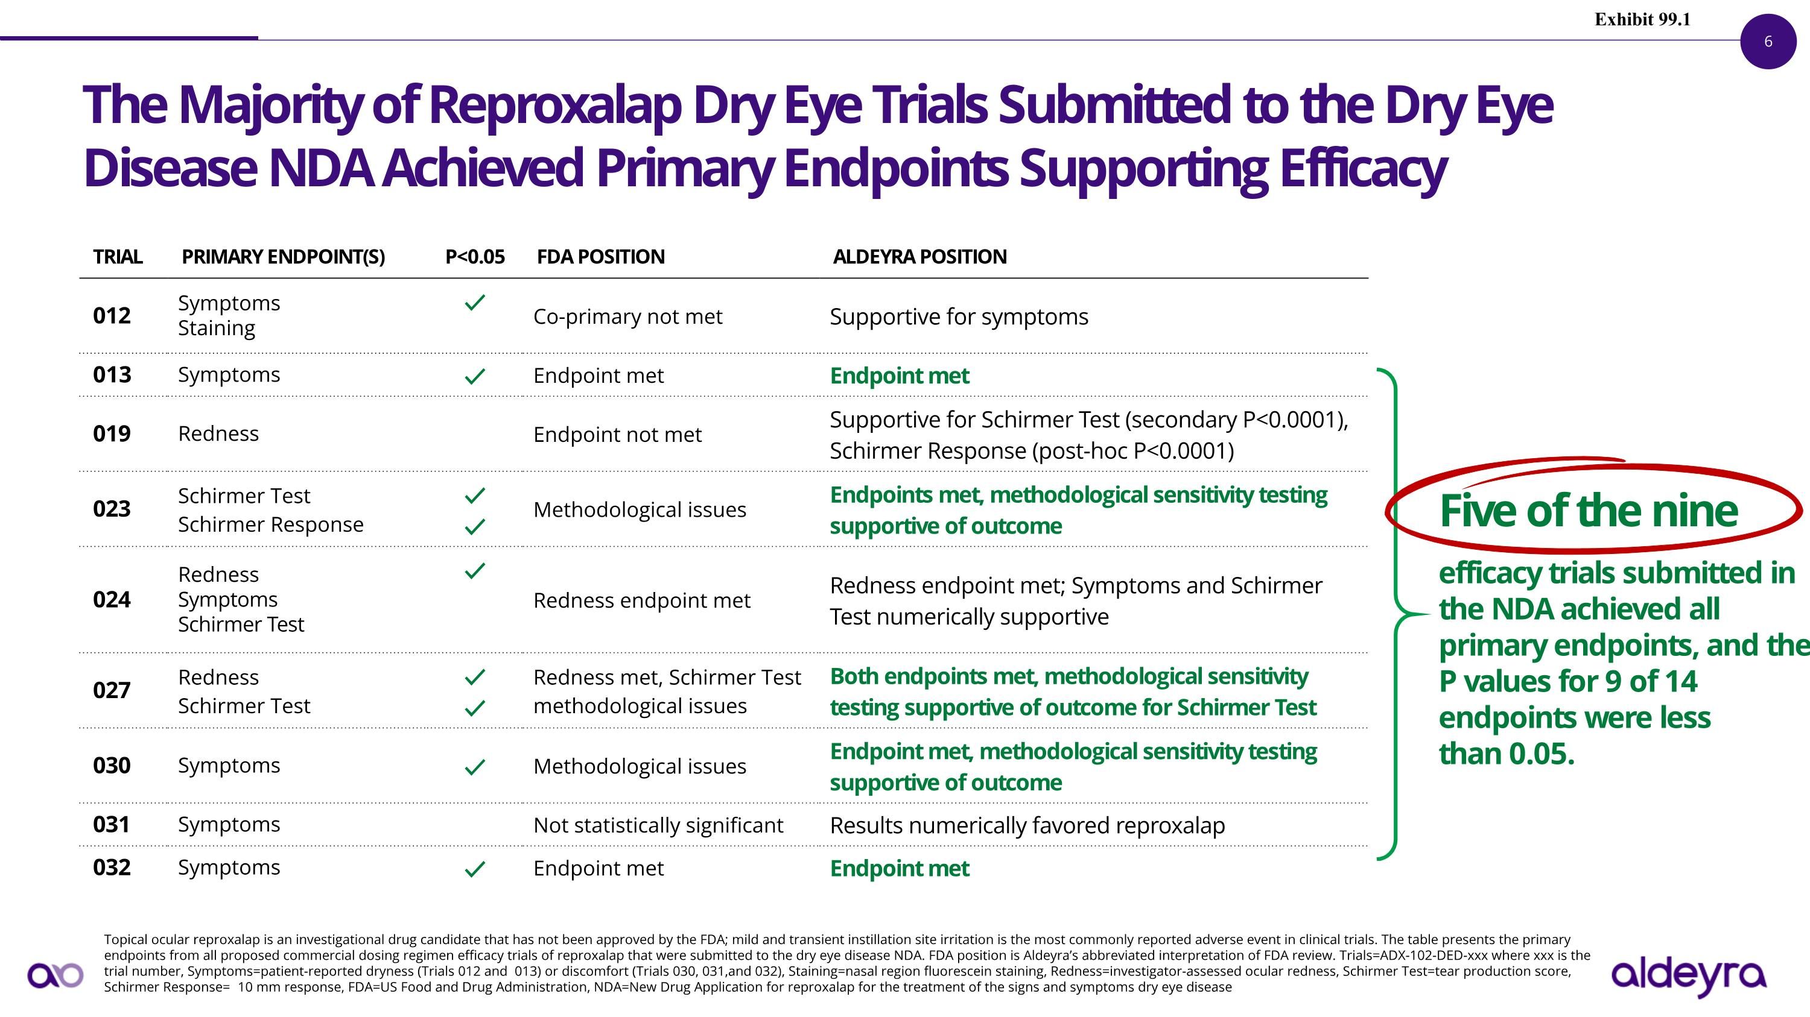
TRIAL PRIMARY ENDPOINT(S) P<0.05 FDA POSITION ALDEYRA POSITION 012 Symptoms Staining ✓ Co-primary not met Supportive for symptoms 013 Symptoms ✓ Endpoint met Endpoint met 019 Redness Endpoint not met Supportive for Schirmer Test (secondary P<0.0001), Schirmer Response (post-hoc P<0.0001) 023 Schirmer Test Schirmer Response ✓ ✓ Methodological issues Endpoints met, methodological sensitivity testing supportive of outcome 024 Redness Symptoms Schirmer Test ✓ Redness endpoint met Redness endpoint met; Symptoms and Schirmer Test numerically supportive 027 Redness Schirmer Test ✓ ✓ Redness met, Schirmer Test methodological issues Both endpoints met, methodological sensitivity testing supportive of outcome for Schirmer Test 030 Symptoms ✓ Methodological issues Endpoint met, methodological sensitivity testing supportive of outcome 031 Symptoms Not statistically significant Results numerically favored reproxalap 032 Symptoms ✓ Endpoint met Endpoint met The Majority of Reproxalap Dry Eye Trials Submitted to the Dry Eye Disease NDA Achieved Primary Endpoints Supporting Efficacy Topical ocular reproxalap is an investigational drug candidate that has not been approved by the FDA; mild and transient instillation site irritation is the most commonly reported adverse event in clinical trials. The table presents the primary endpoints from all proposed commercial dosing regimen efficacy trials of reproxalap that were submitted to the dry eye disease NDA. FDA position is Aldeyra’s abbreviated interpretation of FDA review. Trials=ADX-102-DED-xxx where xxx is the trial number, Symptoms=patient-reported dryness (Trials 012 and 013) or discomfort (Trials 030, 031,and 032), Staining=nasal region fluorescein staining, Redness=investigator-assessed ocular redness, Schirmer Test=tear production score, Schirmer Response=≥10 mm response, FDA=US Food and Drug Administration, NDA=New Drug Application for reproxalap for the treatment of the signs and symptoms dry eye disease Five of the nine efficacy trials submitted in the NDA achieved all primary endpoints, and the P values for 9 of 14 endpoints were less than 0.05. Exhibit 99.1

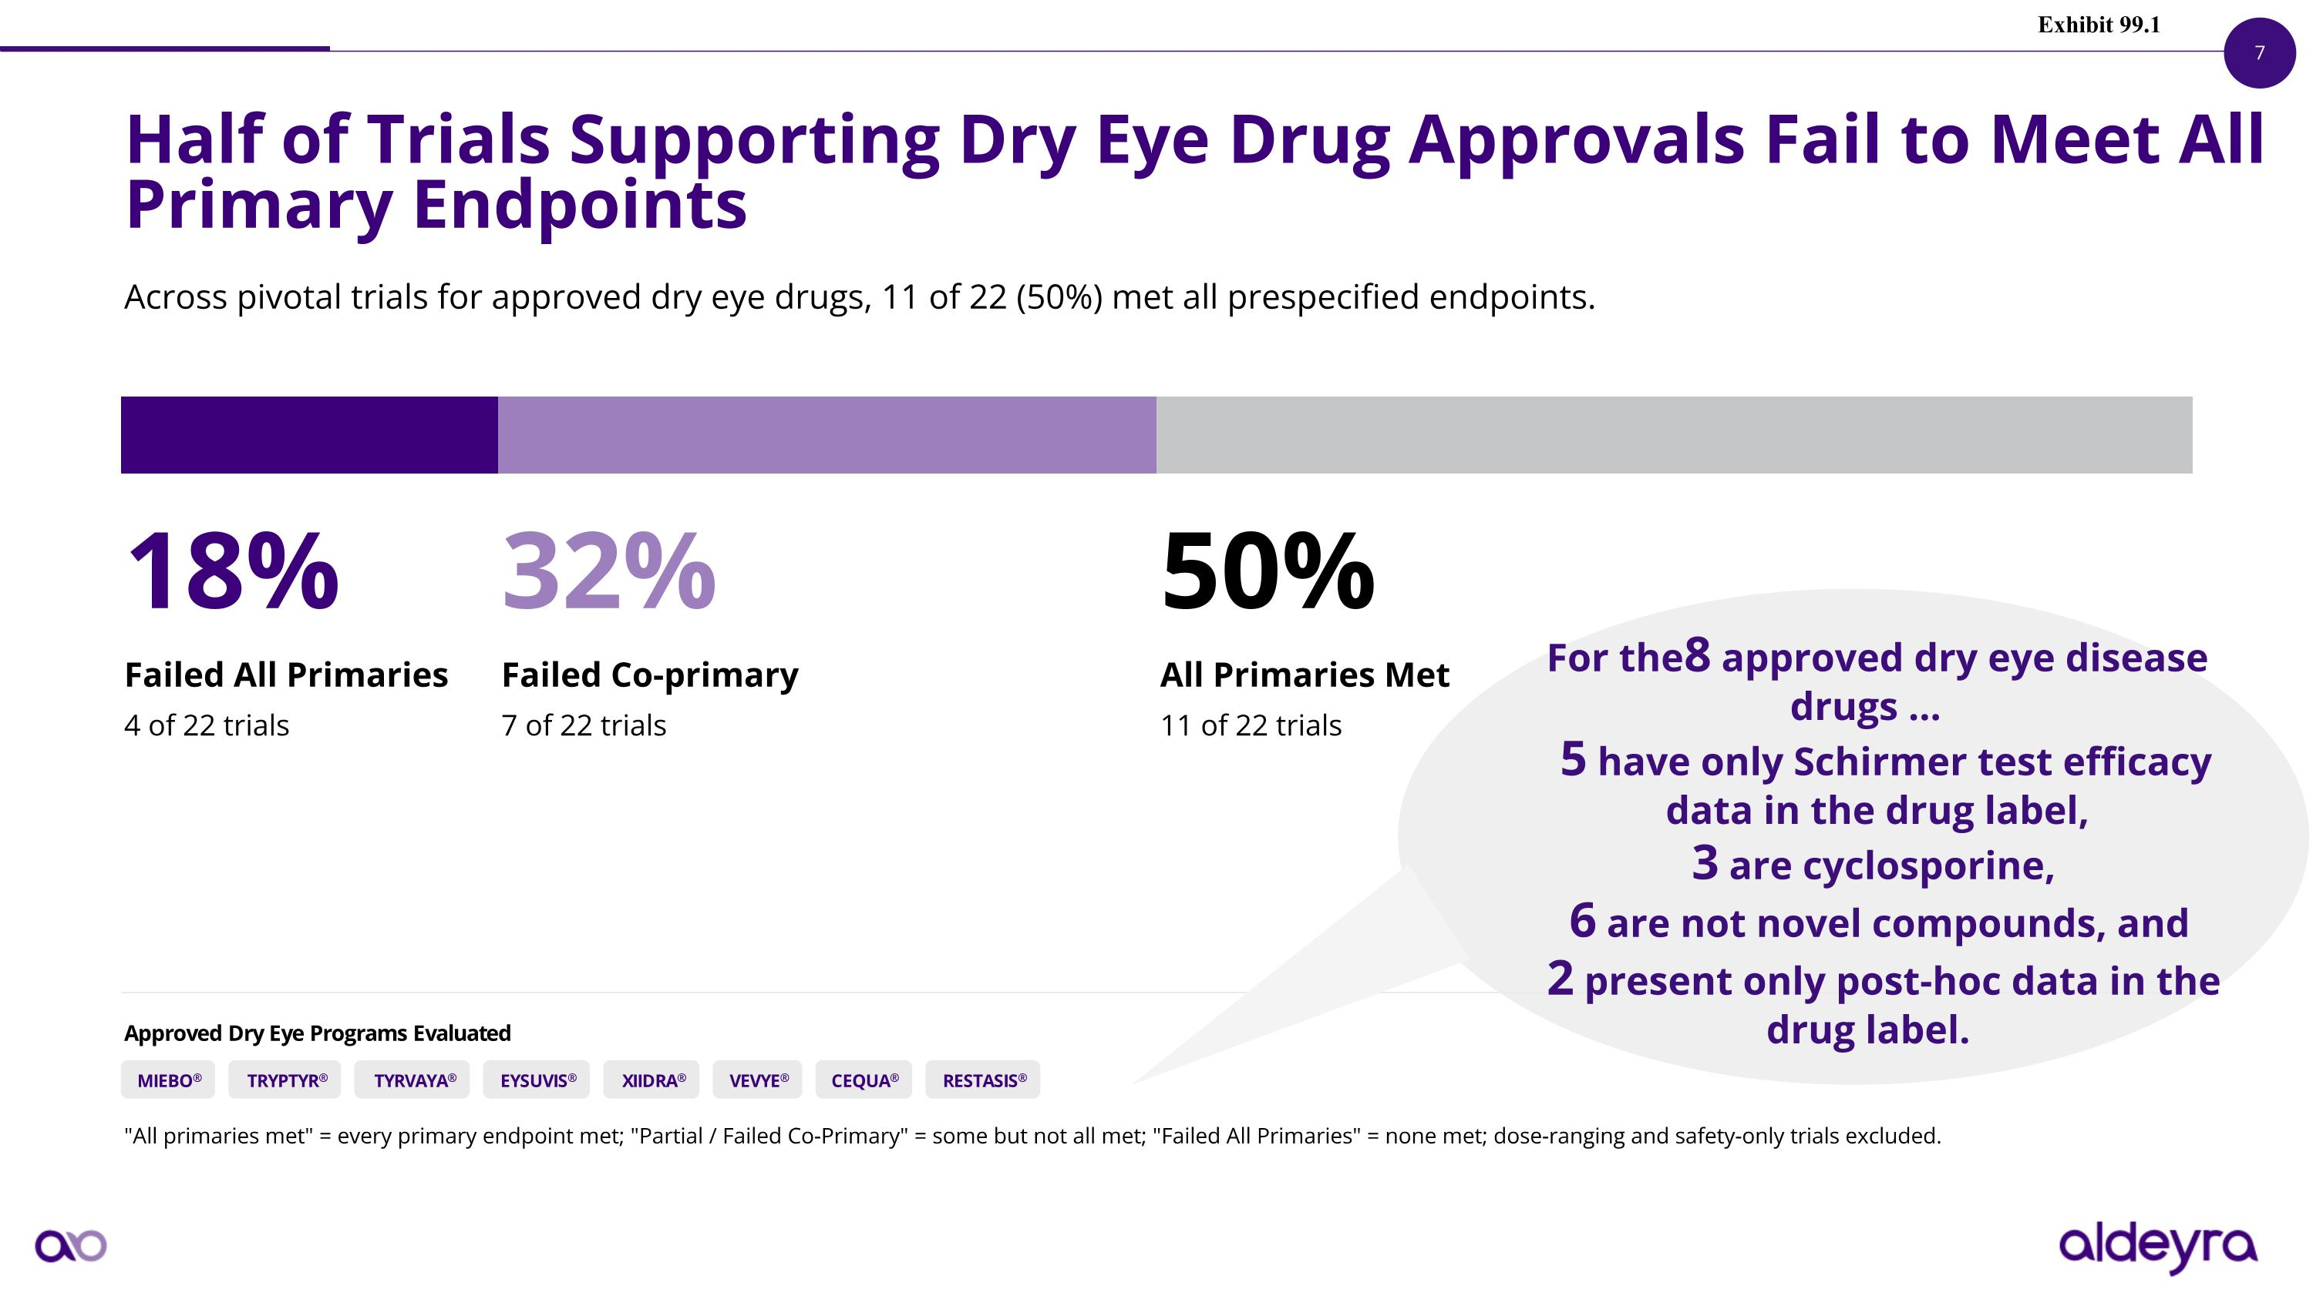
Half of Trials Supporting Dry Eye Drug Approvals Fail to Meet All Primary Endpoints Across pivotal trials for approved dry eye drugs, 11 of 22 (50%) met all prespecified endpoints. 18% Failed All Primaries 4 of 22 trials 32% Failed Co-primary 7 of 22 trials 50% All Primaries Met 11 of 22 trials Approved Dry Eye Programs Evaluated MIEBO® TRYPTYR® TYRVAYA® EYSUVIS® XIIDRA® VEVYE® CEQUA® RESTASIS® "All primaries met" = every primary endpoint met; "Partial / Failed Co-Primary" = some but not all met; "Failed All Primaries" = none met; dose-ranging and safety-only trials excluded. For the 8 approved dry eye disease drugs 5 have only Schirmer test efficacy data in the drug label, 3 are cyclosporine, 6 are not novel compounds, and 2 present only post-hoc data in the drug label. Exhibit 99.1

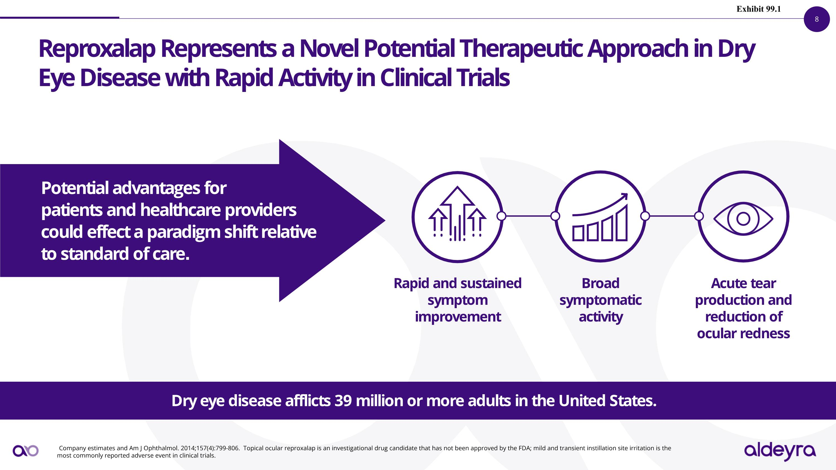
Reproxalap Represents a Novel Potential Therapeutic Approach in Dry Eye Disease with Rapid Activity in Clinical Trials Potential advantages for ?patients and healthcare providers could effect a paradigm shift relative to standard of care. Company estimates and Am J Ophthalmol. 2014;157(4):799-806. Topical ocular reproxalap is an investigational drug candidate that has not been approved by the FDA; mild and transient instillation site irritation is the most commonly reported adverse event in clinical trials. Dry eye disease afflicts 39 million or more adults in the United States. Rapid and sustained symptom improvement Broad ?symptomatic ?activity Acute tear production and reduction of?ocular redness Exhibit 99.1

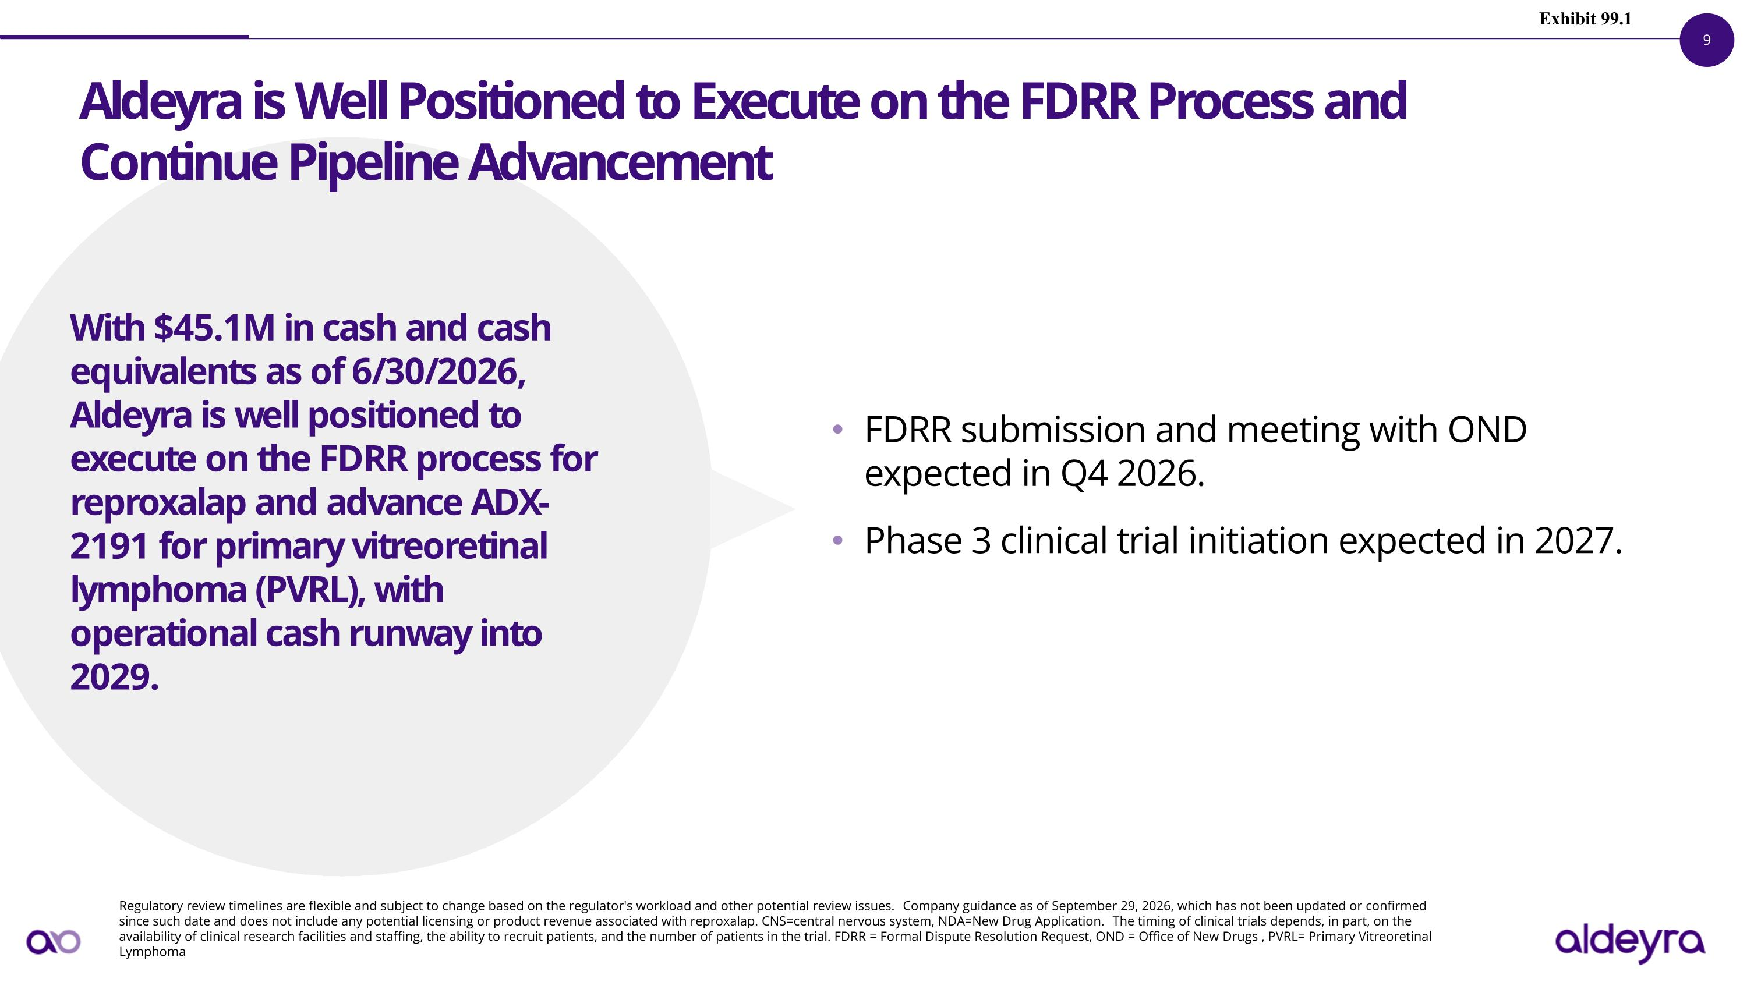
Regulatory review timelines are flexible and subject to change based on the regulator's workload and other potential review issues. Company guidance as of September 29, 2026, which has not been updated or confirmed since such date and does not include any potential licensing or product revenue associated with reproxalap. CNS=central nervous system, NDA=New Drug Application. The timing of clinical trials depends, in part, on the availability of clinical research facilities and staffing, the ability to recruit patients, and the number of patients in the trial. FDRR = Formal Dispute Resolution Request, OND = Office of New Drugs , PVRL= Primary Vitreoretinal Lymphoma FDRR submission and meeting with OND expected in Q4 2026. Phase 3 clinical trial initiation expected in 2027. Aldeyra is Well Positioned to Execute on the FDRR Process and Continue Pipeline Advancement With $45.1M in cash and cash equivalents as of 6/30/2026, Aldeyra is well positioned to execute on the FDRR process for reproxalap and advance ADX-2191 for primary vitreoretinal lymphoma (PVRL), with operational cash runway into 2029. Exhibit 99.1

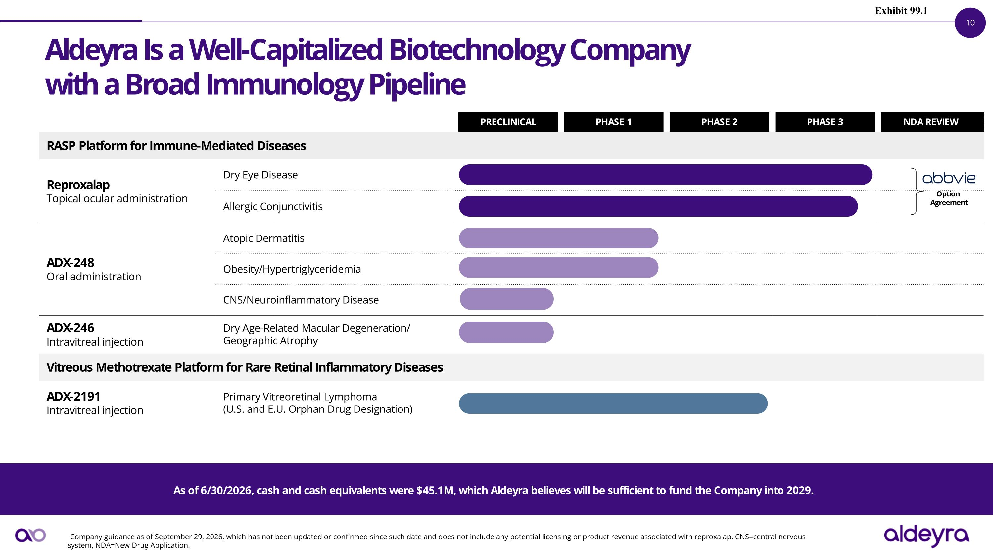
PRECLINICAL PHASE 1 PHASE 2 PHASE 3 NDA REVIEW RASP Platform for Immune-Mediated Diseases Reproxalap Topical ocular administration Dry Eye Disease Dry Eye Disease Allergic Conjunctivitis Allergic Conjunctivitis ADX-248 Oral administration Atopic Dermatitis Sjögren-Larsson Syndrome** Obesity/Hypertriglyceridemia Moderate Alcohol-Associated Hepatitis CNS/Neuroinflammatory Disease ADX-246 Intravitreal injection Dry Age-Related Macular Degeneration/ Geographic Atrophy Sjögren-Larsson Syndrome** Vitreous Methotrexate Platform for Rare Retinal Inflammatory Diseases ADX-2191 Intravitreal injection Primary Vitreoretinal Lymphoma (U.S. and E.U. Orphan Drug Designation) Proliferative Vitreoretinopathy (U.S. FDA Orphan Drug and Fast Track Designation) Aldeyra Is a Well-Capitalized Biotechnology Company?with a Broad Immunology Pipeline Company guidance as of September 29, 2026, which has not been updated or confirmed since such date and does not include any potential licensing or product revenue associated with reproxalap. CNS=central nervous system, NDA=New Drug Application. Option Agreement As of 6/30/2026, cash and cash equivalents were $45.1M, which Aldeyra believes will be sufficient to fund the Company into 2029. Exhibit 99.1

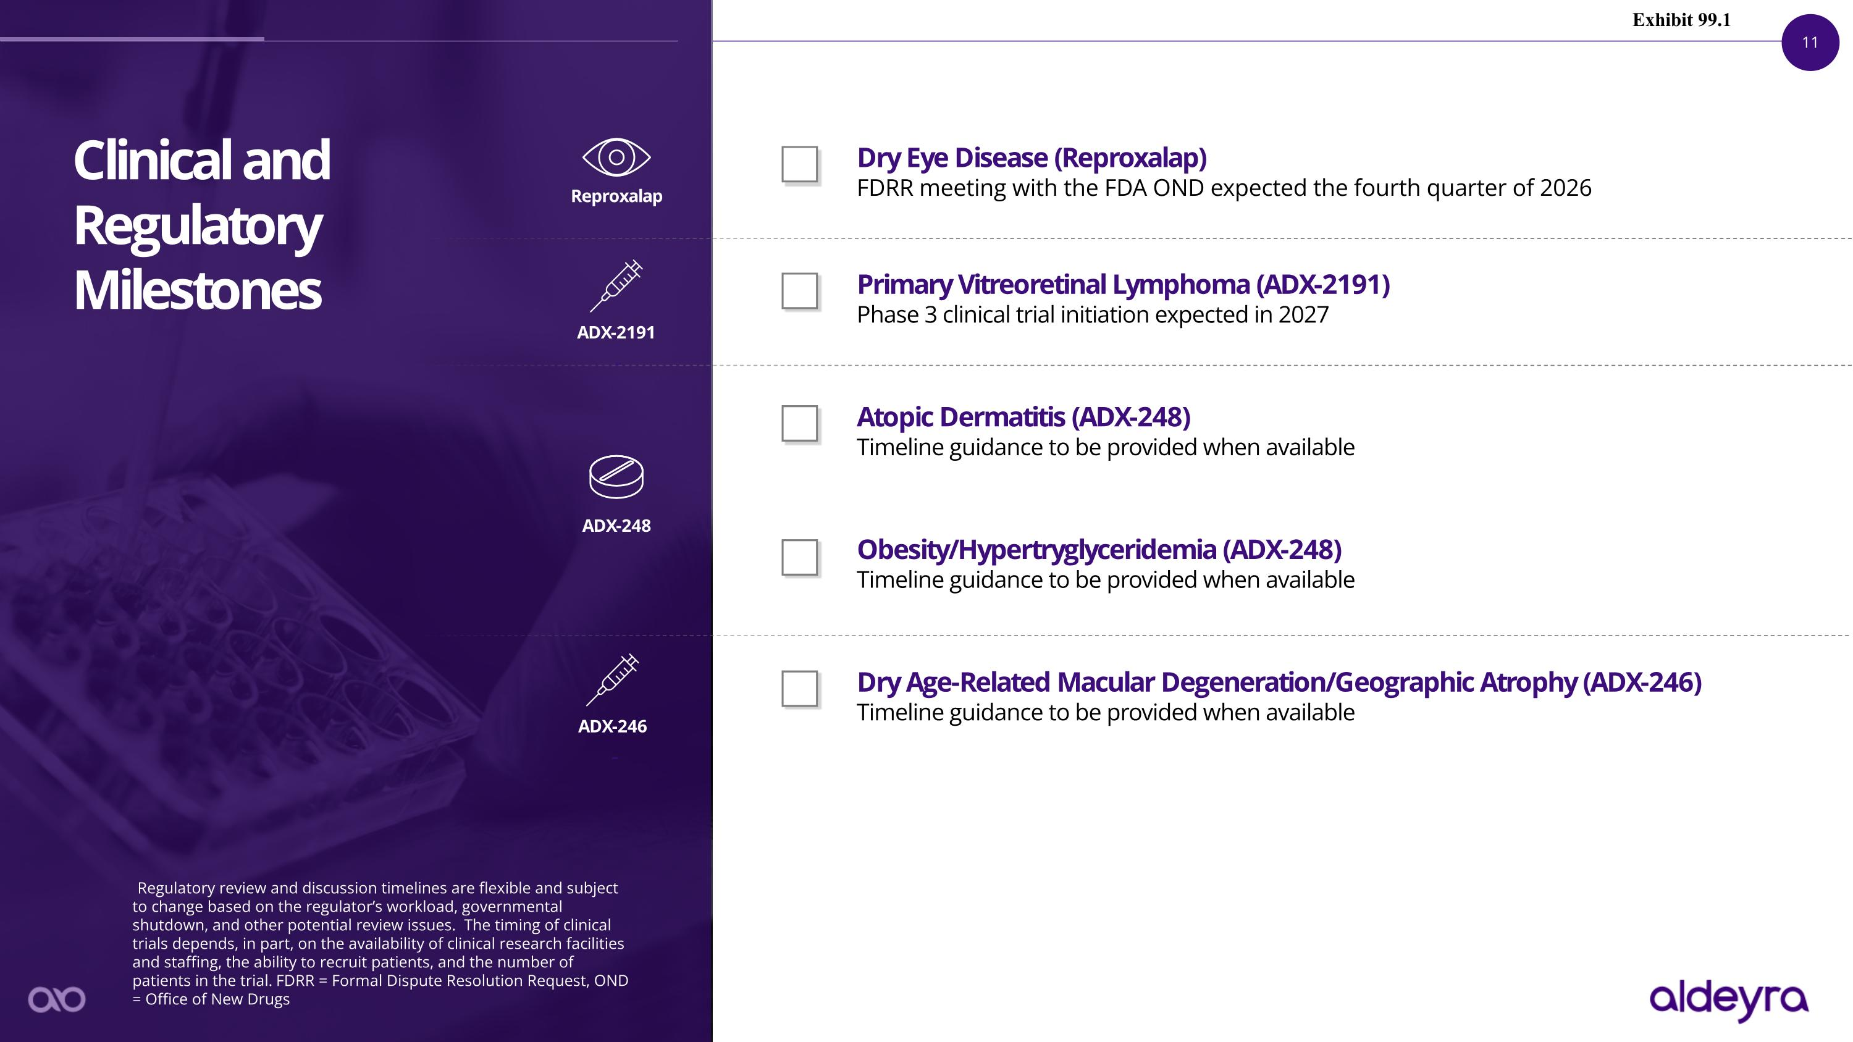
Dry Eye Disease (Reproxalap)?FDRR meeting with the FDA OND expected the fourth quarter of 2026 Primary Vitreoretinal Lymphoma (ADX-2191)?Phase 3 clinical trial initiation expected in 2027 Atopic Dermatitis (ADX-248)?Timeline guidance to be provided when available Obesity/Hypertryglyceridemia (ADX-248)?Timeline guidance to be provided when available Dry Age-Related Macular Degeneration/Geographic Atrophy (ADX-246)?Timeline guidance to be provided when available Clinical and Regulatory Milestones Regulatory review and discussion timelines are flexible and subject to change based on the regulator’s workload, governmental shutdown, and other potential review issues. The timing of clinical trials depends, in part, on the availability of clinical research facilities and staffing, the ability to recruit patients, and the number of patients in the trial. FDRR = Formal Dispute Resolution Request, OND = Office of New Drugs Reproxalap ADX-2191 ADX-248 ADX-246 Exhibit 99.1

Exhibit 99.2

News Release

Aldeyra Therapeutics Announces Intent to Submit Formal Dispute Resolution Request for Reproxalap to Treat Dry Eye Disease

Concord, Mass. September 29, 2026 – Aldeyra Therapeutics, Inc. (Nasdaq: ALDX) (Aldeyra), a biotechnology company devoted to discovering and developing innovative therapies designed to treat immune-mediated diseases, today announced intent to submit to the U.S. Food and Drug Administration (FDA) a Formal Dispute Resolution Request (FDRR) for reproxalap, an
investigational drug candidate, for the treatment of dry eye disease. The FDRR, which is expected to be reviewed by the FDA’s Office of New Drugs (OND), is designed to appeal the March 16, 2026 Complete Response Letter that denied approval of a New Drug Application (NDA) for reproxalap for the treatment of dry eye disease. Submission of the FDRR and a meeting with the OND are expected in the fourth quarter of 2026.

Following an NDA submission and two NDA resubmissions of reproxalap for the treatment of dry eye disease, Aldeyra has received three Complete Response Letters, the first two of which recommended an additional clinical trial to “demonstrate a positive effect on the treatment of ocular symptoms of dry eye” and the most recent of which did not request further clinical trials but stated that the “totality of evidence from the completed clinical trials does not support the effectiveness of the product.” Over the course of the three NDA submissions, Aldeyra has provided data from nine adequate and well-controlled clinical trials, five of which achieved all multiplicity-controlled primary endpoints, consistent with or greater than the success rates of clinical trials conducted for approved dry eye disease products.

The decision to submit the FDRR is based on the outcome of recent Type A and Type D meetings with the FDA Division of Ophthalmology and the Office of Specialty Medicine. Per Prescription Drug User Fee Act target timelines established for the FDRR process, Aldeyra expects to hold a meeting with OND in the fourth quarter of 2026. The timing of the OND FDRR decision will depend on a number of factors, including whether the deciding official requests additional information or determines there is a need to discuss the FDRR with internal or external experts or convene an advisory panel, the occurrence and timing of which are uncertain.

“We remain steadfast in our commitment to working with the FDA to provide a novel therapeutic approach for the treatment of dry eye disease, a condition often regarded by patients and physicians as inadequately addressed by available therapies,” stated Todd C. Brady, M.D., Ph.D., President and Chief Executive Officer of Aldeyra Therapeutics. “Based on the activity of reproxalap across a number of clinical trial designs, and against a backdrop of FDA dry eye disease product approvals that have applied considerable discretion, we are optimistic in the outcome of the FDRR.”

Exhibit 99.2

Additionally, based on reported cash and cash equivalents of $45.1M as of June 30, 2026, Aldeyra updated financial guidance to include extension of operational cash runway into 2029.

Conference Call & Webcast Information
Aldeyra will host a conference call at 8:00 a.m. ET today to discuss the FDRR. The dial-in numbers are (833) 461-5787 for domestic callers and (585) 542-9983 for international callers. The access code is 720 219 137. A live webcast of the conference call will be available on the Investor Relations page of the company’s website at https://ir.aldeyra.com. After the live webcast, the event will remain archived on the Aldeyra Therapeutics website for 90 days.

About Aldeyra
Aldeyra Therapeutics is a biotechnology company devoted to discovering innovative therapies designed to treat immune-mediated diseases. Our approach is to develop pharmaceuticals that modulate protein systems, instead of directly inhibiting or activating single protein targets, with the goal of optimizing multiple pathways at once while minimizing toxicity. Our product candidates include RASP (reactive aldehyde species) modulators ADX-248 and chemically related molecules for the potential treatment of systemic and retinal immune-mediated diseases. Our late-stage product candidates are reproxalap, a RASP modulator for the potential treatment of dry eye disease and allergic conjunctivitis, and ADX-2191, a novel formulation of intravitreal methotrexate for the potential treatment of primary vitreoretinal lymphoma.

Safe Harbor Statement
This release contains forward-looking statements within the meaning of the Private Securities Litigation Reform Act of 1995, including, but not limited to, statements regarding Aldeyra’s future expectations, plans, and prospects, including without limitation statements regarding: the goals, opportunity, and potential for reproxalap; the outcome and expected timing of discussions with the FDA; the timing and outcome of the expected FDRR submission; and projected operational cash runway. Aldeyra intends such forward-looking statements to be covered by the safe harbor provisions for forward-looking statements contained in Section 21E of the Securities Exchange Act of 1934 and the Private Securities Litigation Reform Act of 1995. In some cases, you can identify forward-looking statements by terms such as, but not limited to, “may,” “might,” “will,” “objective,” “intend,” “should,” "could," “can,” “would,” “expect,” “believe,” “anticipate,” “project,” “on track,” “scheduled,” “target,” “design,” “estimate,” “predict,” “contemplates,” “likely,” “potential,” “continue,” “ongoing,” “aim,” “plan,” or the negative of these terms, and similar expressions intended to identify forward-looking statements. Such forward-looking statements are based upon current expectations that involve risks, changes in circumstances, assumptions, and uncertainties. Aldeyra is at an early stage of development and may not ever have any products that generate significant revenue. All of Aldeyra's development timelines may be subject to adjustment depending on recruitment rate, regulatory review, preclinical and clinical results, funding, and other factors that could delay the initiation, enrollment, or completion of clinical trials. Important factors that could cause actual results to differ materially from those reflected in Aldeyra's forward-looking statements include, among others, the timing of enrollment, commencement and completion of Aldeyra's clinical trials, the timing and success of preclinical studies and clinical trials conducted by Aldeyra and its development partners; delay in or failure to obtain regulatory approval of Aldeyra's product candidates, including as a result of

Exhibit 99.2
the FDA not accepting Aldeyra’s regulatory filings, issuing a complete response letter, or requiring additional clinical trials or data prior to review or approval of such filings or in connection with resubmissions of such filings; the ability to maintain regulatory approval of Aldeyra's product candidates, and the labeling for any approved products; the risk that prior results, such as signals of safety, activity, or durability of effect, observed from preclinical or clinical trials, will not be replicated or will not continue in ongoing or future studies or clinical trials involving Aldeyra's product candidates in clinical trials focused on the same or different indications; updated or refined data based on Aldeyra's continuing or post-hoc review and quality control analysis of clinical data; the scope, progress, expansion, and costs of developing and commercializing Aldeyra's product candidates; uncertainty as to Aldeyra’s ability to commercialize (alone or with others) and obtain reimbursement for Aldeyra's product candidates following regulatory approval, if any; the size and growth of the potential markets and pricing for Aldeyra's product candidates and the ability to serve those markets; Aldeyra's expectations regarding Aldeyra's expenses and future revenue, the timing of future revenue, the sufficiency or use of Aldeyra's cash resources and needs for additional financing; the rate and degree of market acceptance of any of Aldeyra's product candidates; Aldeyra's expectations regarding competition; Aldeyra's anticipated growth strategies; Aldeyra's ability to attract or retain key personnel; Aldeyra’s commercialization, marketing and manufacturing capabilities and strategy; Aldeyra's ability to establish and maintain development partnerships; Aldeyra’s ability to successfully integrate acquisitions into its business; Aldeyra's expectations regarding federal, state, and foreign regulatory requirements; political, economic, legal, social, and health risks, public health measures, and war or other military actions, that may affect Aldeyra’s business or the global economy; regulatory developments in the United States and foreign countries; Aldeyra's ability to obtain and maintain intellectual property protection for its product candidates; the anticipated trends and challenges in Aldeyra's business and the market in which it operates; and other factors that are described in the “Risk Factors” and “Management's Discussion and Analysis of Financial Condition and Results of Operations” sections of Aldeyra's Annual Report on Form 10-K for the year ended December 31, 2025 and Aldeyra’s Quarterly Report on Form 10-Q for the quarter ended June 30, 2026, which are on file with the Securities and Exchange Commission (SEC) and available on the SEC's website at https://www.sec.gov/. Additional factors may be described in those sections of Aldeyra’s Quarterly Report on Form 10-Q for the quarter ended September 30, 2026, expected to be filed with the SEC in the fourth quarter of 2026, and Aldeyra’s other filings with the SEC.

In addition to the risks described above and in Aldeyra's other filings with the SEC, other unknown or unpredictable factors also could affect Aldeyra's results. No forward-looking statements can be guaranteed and actual results may differ materially from such statements. The information in this release is provided only as of the date of this release, and Aldeyra undertakes no obligation to update any forward-looking statements contained in this release on account of new information, future events, or otherwise, except as required by law.

Investor & Media Contact:
David Burke
(917) 618-2651
investorrelations@aldeyra.com

